Clinical Medicine and Surgery I · Exam 3 — Study Guide
Editable Word copy of the PA_Quizzes study aid. Headings use real Word styles, so the navigation pane and the contents field below both work, and restyling one heading restyles them all.
[In Word: right-click here and choose Update Field to build the contents.]

1 · Disorders of the External and Middle Ear
INSTRUCTIONAL OBJECTIVES
DISORDERS OF THE EARS, NOSE, THROAT AND NECK — External and Middle Ear Disorders
- Compare and contrast the etiologies, epidemiology, risk factors, clinical manifestations, differential diagnosis, diagnostic testing (including ordering and interpretation), management (acute and chronic, including applicable rehabilitative and palliative care), appropriate referrals, patient education, and prognosis of the following external and middle ear conditions:
- Acute otitis media
- Barotrauma
- Cerumen impaction
- Cholesteatoma
- Chronic otitis media
- Eustachian tube dysfunction
- Ear trauma
- Blunt and penetrating trauma
- Tympanic membrane perforation
- Hematoma of external ear
- Foreign body in the ear
- Otitis externa
- Otosclerosis
- Neoplasms: a. Benign · b. Malignant
- Identify medical care strategies for external and middle ear disorders in the lecture topic list for the following populations: 1. adolescent · 2. adult · 3. elderly

NOTE
Two things he said out loud that are on no slide. The otitis media slide lists three bacteria and nothing else, which reads as though the disease were bacterial. It is not: “far and away the most common cause for otitis media is a viral infection”. And the three-organism sequence is no longer in order of prevalence — Moraxella catarrhalis has overtaken Haemophilus influenzae because of vaccination, which is why immunisation status is worth asking. An unimmunised child puts H. influenzae back on the list.
His emphasis marker is repetition. He said “it's important, it's important, it's important to remember the three most common bacterial causes” — S. pneumoniae, H. influenzae, M. catarrhalis — and pointed out he had highlighted them on the slide himself. He signposted the exam nowhere else in the entire lecture, so his silence elsewhere means nothing.

NOTE
Mastoiditis is filed here, though the syllabus lists it under Lecture 16. The only teaching on it in either deck is one line of this lecture’s slide 19, as a complication of acute otitis media. It sits where the content is.
The three columns to read down. Ear disease sorts on pain, the type of hearing loss and what the drum looks like. Those three are printed under every condition below and are the axes of the comparison chart.

1.1 · The external canal

Cerumen impaction Routine
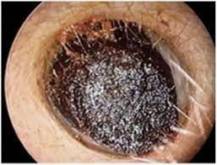
Cerumen impaction Slide 26
Gives itself away by: Self-induced by cleaning · wax filling the canal · conductive loss that clears on removal
Presentation & who gets itCerumen is a protective, thick, oily secretion of the outer third of the canal, and the canal is normally self-cleansing. Impaction is most commonly self-induced by cleaning attempts that push wax deeper. May be asymptomatic, or cause pruritus, fullness and conductive hearing loss.Pain / hearing loss / key findingNo — pruritus, fullness · Conductive · Wax obstructing the canalTesting & causeOtoscopy: visible cerumen fully or partially obstructing the canal, wet and sticky, dry and flaky, or dark.First-line treatmentOver-the-counter otic preparations to soften it. Irrigation or suction in clinic — irrigation uses body-temperature water and ONLY if the drum is intact. Curette removal suits soft wax and a compliant patient. If tympanostomy tubes or a perforation are present, removal must be done by ENT.Education & prognosisDo not insert anything into the canal. If cleaning is wanted, a washcloth over the index finger at the opening is the whole technique.
Slides 27–29

Otitis externa Routine
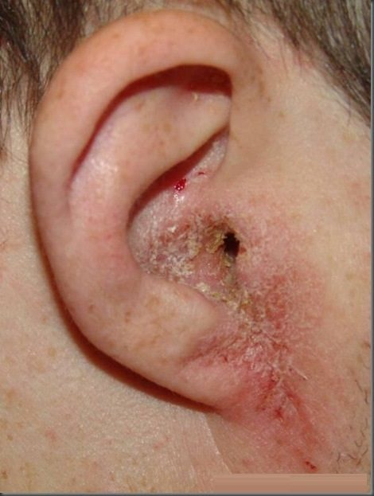
Otitis externa Slide 58
Gives itself away by: Pain on moving the tragus · swimmer · discharge from the canal
Presentation & who gets itInflammation and infection of the external canal, affecting 10% of people in their lifetime, all ages but commonest in children and early adolescence and in summer. Organisms: P. aeruginosa 38%, S. epidermidis 9%, S. aureus 8%; other bacteria and fungi possible. Risk factors: moisture and swimming, epithelial damage from aggressive cleaning, foreign bodies such as cotton swab fibres, occlusion by hearing aids or headphones, dermatitis of the auricle, radiation. Symptoms: otalgia exacerbated by touching or moving the auricle or tragus, otorrhoea, pruritus, fullness, reduced hearing.Pain / hearing loss / key findingYES — worse on moving the tragus · Conductive if the canal closes · Canal erythematous and oedematousTesting & causeClinical diagnosis. Cultures reserved for severe, chronic or recurrent infection, immunosuppression, post-operative infection and treatment failure. Examination: tenderness to palpation, visible discharge, erythema and oedema of the canal, periauricular and anterior cervical lymphadenopathy, thickened canal skin in chronic disease. Differential: otomycosis, suppurative otitis media, contact dermatitis, psoriasis and the rare carcinoma of the ear canal.First-line treatmentRemove debris, then otic drops: antiseptic (boric acid, ichthammol, phenol, aluminium acetate, gentian violet, thymol, cresylate, alcohol), antibiotic (ofloxacin, ciprofloxacin, colistin, polymyxin B, neomycin, chloramphenicol, gentamicin, tobramycin) or acidifying (acetic acid). Combination drops with a steroid reduce pain and inflammation. An ear wick if the canal is stenosed.Education & prognosisKeep the ear dry, stop cleaning it, and use the drops for the full course — the pain settles well before the infection does.
Slides 54–59

Malignant otitis externa Emergent
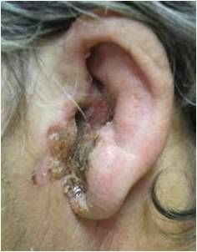
Malignant otitis externa Slide 61
Gives itself away by: Elderly diabetic · pain out of proportion to the exam · facial nerve weakness
Presentation & who gets itAlso called necrotizing external otitis. A severe and potentially fatal infection of the bone and marrow spaces of the skull base and the soft tissue and cartilage of the temporal region. Elderly diabetics and immunocompromised patients are most at risk. Over 95% is spread of P. aeruginosa from an otitis externa. Symptoms: severe otalgia out of proportion to the physical findings, copious otorrhoea, sometimes visible necrosis of the canal and evidence of facial nerve weakness.Pain / hearing loss / key findingSEVERE — out of proportion · Conductive · Canal necrosis, facial nerve weaknessTesting & causeMRI or CT shows infection in the bony structures — that is what separates it from ordinary otitis externa.First-line treatmentAntipseudomonal antibiotics — for example ciprofloxacin.Education & prognosisThe complaint that matters is pain far worse than the ear looks, in a diabetic or immunocompromised patient. That combination is not treated as a routine swimmer's ear.
Slides 61

Otomycosis Routine
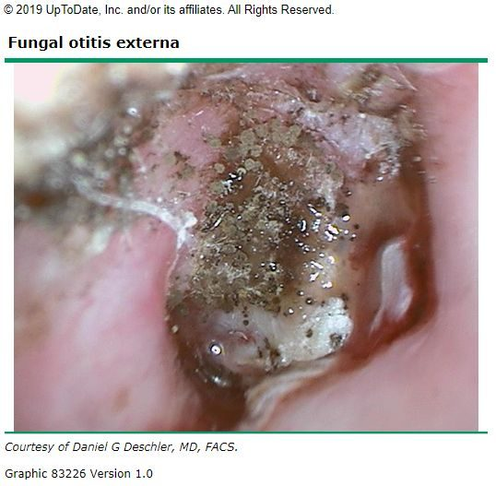
Otomycosis Slide 63
Gives itself away by: Itch more than pain · “wet newspaper” spores or white curd
Presentation & who gets itFungal infection of the external canal, 9% of ear canal infections and varying with climate. Commonest organisms Aspergillus niger and Candida. Pruritus, discomfort that is less painful than bacterial otitis externa, otorrhoea, foreign body sensation.Pain / hearing loss / key findingLess than bacterial — itch dominates · Conductive if obstructing · “Wet newspaper” or white curdTesting & causeOtoscopy is the diagnosis. Aspergillus: visible fungal spores and filaments, described as “wet newspaper”. Candida: white, fluffy, curd-like material. Mild to moderate oedema.First-line treatmentDebris removal and topical antifungals.Education & prognosisIt is treated by cleaning the canal as much as by the drops; the itch outlasting the pain is the clue that it is fungal.
Slides 62–63

Foreign body of the canal Urgent
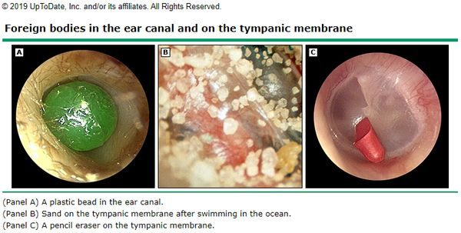
Foreign body of the canal Slide 49
Gives itself away by: Child · anything that fits · do not push it deeper
Presentation & who gets itCommoner in children but possible at any age, and can be anything that fits — beads, popcorn, crayons, insects, pencil erasers, paper. Otalgia varies with the shape of the object; bloody discharge if the canal lining is damaged; fullness and foreign body sensation.Pain / hearing loss / key findingVaries with the object · Conductive if obstructing · Object in the canalTesting & causeOtoscopy.First-line treatmentCAUTION — do not push the object deeper. Firm objects come out with a loop or hook, soft ones with alligator forceps. Irrigation only if the drum is known to be intact, and with care: organic objects swell when wet and lodge harder. Insects are immobilised first by filling the canal with lidocaine — again only if the drum is intact. Refer to ENT for removal under microscopy where warranted.Education & prognosisNothing goes into the ear at home to fetch it out; attempts are what turn a simple removal into a referral.
Slides 49–50

1.2 · The auricle

Hematoma of the external ear Urgent
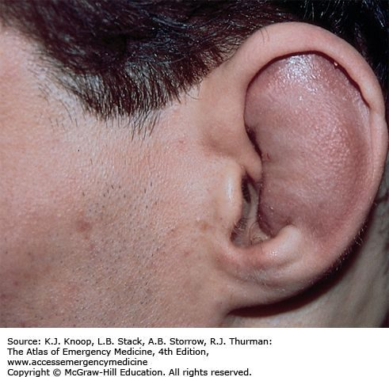
Hematoma of the external ear Slide 40
Gives itself away by: Blunt trauma · cartilaginous landmarks lost · drain early or cauliflower ear
Presentation & who gets itBlood pooling in the sub-perichondrial space, usually after blunt trauma. The collection keeps oxygen and nutrients from the cartilage, which is what risks necrosis. May develop hours after the injury, so patients are re-checked at 12–24 hours. Examination: oedema and ecchymosis of the auricle with loss of the cartilaginous landmarks.Pain / hearing loss / key findingYES · None · Auricle swollen, landmarks lostTesting & causeClinical.First-line treatmentDrain it — incision or large-needle aspiration — and do it early. After 7 days granulation tissue makes drainage much harder. Follow with irrigation and topical and/or systemic antibiotics. Ear splinting improves the cosmetic result and prevents re-accumulation: cotton bolsters, plaster moulds, silicone putty, thermoplastic splints.Education & prognosisEarly diagnosis and drainage is what prevents cauliflower ear. Come back at 12–24 hours even if it looks minor, because the haematoma can appear late.
Slides 39–42

Lacerations and avulsion Urgent
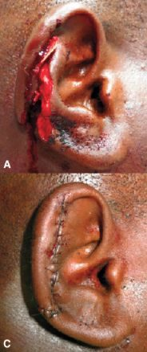
Lacerations and avulsion Slide 43
Gives itself away by: Blunt or sharp trauma to the auricle · prompt repair · pressure dressing after
Presentation & who gets itBlunt or sharp trauma to the auricle. Prompt repair and infection prevention are critical. Simple lacerations close with sutures; complex ones and avulsions may need debridement first; tissue grafts if there is tissue loss. If avulsed tissue is recovered, reattachment is often successful.Pain / hearing loss / key findingYES · None · Visible wound of the auricleTesting & causeClinical.First-line treatmentRepair as above, then cover with a pressure dressing to prevent a haematoma forming under the repair.Education & prognosisBring any avulsed tissue — reattachment often works.
Slides 43

Foreign body of the auricle Urgent
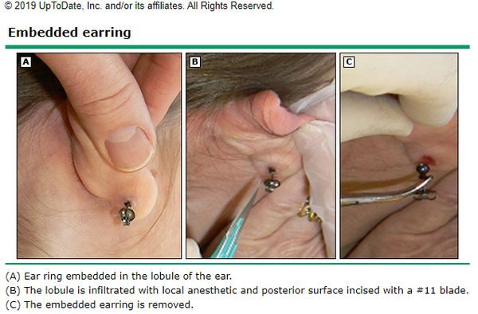
Foreign body of the auricle Slide 52
Gives itself away by: Embedded earring · girls and young adolescents · infection is the concern
Presentation & who gets itPiercings becoming embedded in the earlobe or elsewhere on the auricle. Most common in girls and young adolescents with pierced ears. Pain, erythema and oedema; may have purulent drainage from the piercing site. Examination: pain on palpation, and the foreign body may be palpable.Pain / hearing loss / key findingYES · None · Embedded piercingTesting & causeClinical.First-line treatmentRemoval under local anaesthetic; younger or non-compliant patients may need sedation.Education & prognosisInfection is the biggest concern, not the object itself.
Slides 51–52

Keloid of the ear Routine
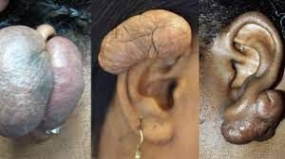
Keloid of the ear Slide 69
Gives itself away by: Hypertrophic scar after trauma — classically after piercing
Presentation & who gets itBenign neoplasm of the ear: keloid and hypertrophic scars resulting from trauma.Pain / hearing loss / key findingNo · None · Scar on the auricleTesting & causeClinical.First-line treatmentAvoid further trauma. Intralesional steroid injection, corticosteroid tape, excision. Radiation therapy in adults, NEVER in children. Follow closely for recurrence.Education & prognosisRecurrence is the rule rather than the exception, which is why follow-up is part of the treatment.
Slides 69–70

1.3 · The eustachian tube and pressure

Eustachian tube dysfunction Routine
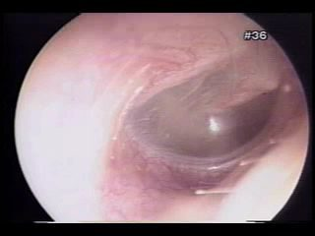
Eustachian tube dysfunction Slide 9
Gives itself away by: Fullness after a cold · crackling or popping on swallowing · retracted drum
Presentation & who gets itOedema of the tube lining after an upper respiratory infection or allergy stops the tube equalising pressure. Fullness, mild to moderate hearing impairment, and crackling or popping with yawning or swallowing, which indicates the blockage is only partial. Usually transient — days to weeks.Pain / hearing loss / key findingNo — fullness · Conductive, mild to moderate · Retracted drum, reduced mobilityTesting & causeClinical. Otoscopy: retraction of the tympanic membrane and decreased mobility on insufflation. Tympanometry, taught in the next lecture, shows a negative pressure peak.First-line treatmentSystemic or intranasal decongestants and intranasal corticosteroids. Forced exhalation against resistance. Caution with active nasal discharge — that manoeuvre can force infected fluid into the middle ear and trigger acute otitis media.Education & prognosisAvoid air travel and other pressure changes until symptoms resolve. It is the commonest single reason an ear will not clear on a plane.
Slides 6–10

Barotrauma Routine
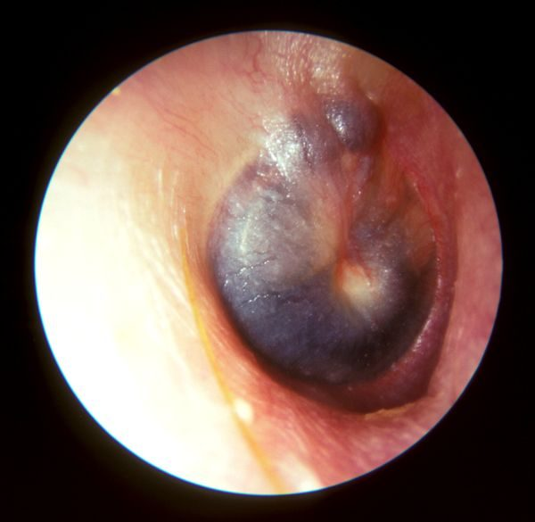
Barotrauma Slide 59
Gives itself away by: Cannot equalise · flying or SCUBA · haemotympanum behind the drum
Presentation & who gets itInability to equalise middle ear pressure, seen with air travel, rapid altitude change and SCUBA diving. May rupture the tympanic membrane or bleed into the middle ear. Otalgia and conductive hearing loss.Pain / hearing loss / key findingYES — otalgia · Conductive; sensorineural if the window ruptures · Haemotympanum, reduced mobilityTesting & causeOtoscopy: decreased mobility on insufflation, visible haemotympanum if there is haemorrhage, visible perforation if present. Severe cases can rupture the round or oval window, adding tinnitus, sensorineural hearing loss, vertigo, nausea and vomiting — that combination means the inner ear is involved.First-line treatmentEqualise by swallowing, yawning, exhaling through the nose against resistance. Oral or intranasal decongestants may help. Myringotomy gives instant relief and is reserved for severe otalgia and hearing loss with an intact membrane (ENT). Recurrent episodes in frequent flyers may justify tympanostomy tubes (ENT).Education & prognosisAvoid pressure changes while a respiratory illness or allergy flare is active. If flying is unavoidable, take a decongestant beforehand and equalise on descent.
Slides 22–25

1.4 · The otitis media family

Acute otitis media Routine
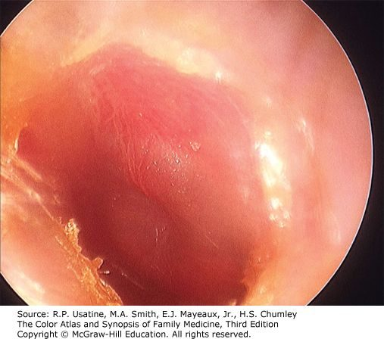
Acute otitis media Slide 16
Gives itself away by: Bulging, erythematous drum · otalgia and fever after a cold · child around 2 years
Presentation & who gets itRapid-onset middle ear inflammation, most often following an upper respiratory illness. Commonest in children, peak incidence around age 2; adults are only 3–15% of diagnoses. Otalgia, fever, hearing loss. Suppurative form discharges into the canal through a perforation. Recurrent means 3 or more episodes in 6 months, or more than 4 in 12 months, with complete resolution between.Pain / hearing loss / key findingYES — otalgia with fever · Conductive · Bulging, erythematous drumTesting & causeDiagnosed clinically. Otoscopy: erythematous and/or bulging drum, purulent effusion often visible, decreased mobility on pneumatic otoscopy, sometimes palpable cervical nodes. Tympanometry optional. Far and away the commonest cause is VIRAL — the slide lists only bacteria. The three bacterial organisms are S. pneumoniae, H. influenzae and M. catarrhalis. That sequence used to run in order of prevalence; M. catarrhalis has now overtaken H. influenzae because of vaccination, so ask the immunisation status — an unimmunised child puts H. influenzae back on the list.First-line treatmentMost episodes resolve spontaneously. Antibiotics for bacterial involvement — amoxicillin. Analgesics and antipyretics for the pain and fever. Tympanostomy tubes for refractory or recurrent episodes, or when complications are present (ENT).Education & prognosisExplain that most cases settle on their own, so a wait-and-see period is not neglect — most of these are viral. Return if pain worsens or discharge appears.
Slides 12–19

Otitis media with effusion Routine
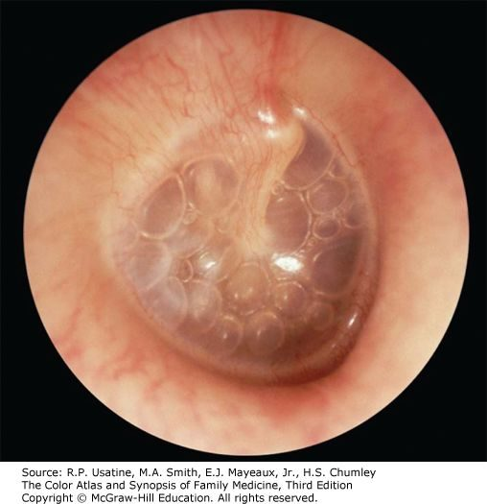
Otitis media with effusion Slide 16
Gives itself away by: Dull drum with an air–fluid level · often asymptomatic · found incidentally
Presentation & who gets itMiddle ear inflammation with an effusion but without acute infection. Follows eustachian tube dysfunction trapping fluid, and often persists after a bacterial acute otitis media has resolved. Often asymptomatic and picked up incidentally on otoscopy; otherwise hearing loss and fullness.Pain / hearing loss / key findingNO — often asymptomatic · Conductive, temporary · Dull drum, air–fluid levelTesting & causeClinical. Otoscopy: dull tympanic membrane, air/fluid level often visible, decreased mobility on pneumatic otoscopy. Tympanometry optional — a type B curve fits the stiff, fluid-filled middle ear.First-line treatmentMost resolve spontaneously. The decision to intervene turns on how long the fluid has been there, the degree of hearing loss, and the effect on speech and language development. Tympanostomy tubes (ENT); adenoidectomy if hypertrophy is obstructing the tubes (ENT).Education & prognosisIn a child the risk is not the ear but the speech and language delay from months of muffled hearing — which is why duration matters more than the appearance.
Slides 13–19

Chronic otitis media Routine
Gives itself away by: Non-healing perforation · recurrent infection · persistent drainage
Presentation & who gets itRecurrent infection with a non-healing perforation of the tympanic membrane. Duration required for diagnosis is controversial — weeks to months. Three subtypes: benign (dry perforation, no active infection); with effusion, also called chronic serous otitis media (continuous serous drainage through the perforation); and chronic suppurative (persistent purulent drainage).Pain / hearing loss / key findingVaries with activity · Conductive · Non-healing perforationTesting & causeClinical, on the persistent perforation and drainage. Audiometry for the associated conductive loss.First-line treatmentRefer to ENT.Education & prognosisThe perforation is the disease, not just its aftermath — water precautions and follow-up matter because it will not close on its own.
Slides 20

Mastoiditis Urgent
Gives itself away by: Complication of acute otitis media · infection spreading to the mastoid air cells
Presentation & who gets itSpread of acute otitis media infection into the mastoid air cells. Listed with tympanic membrane perforation, labyrinthitis and the rare meningitis or encephalitis as the complications of acute otitis media.Pain / hearing loss / key findingYES · Conductive · Complication of acute otitis mediaTesting & causeSuspected clinically in a child with acute otitis media who is not improving. Imaging defines the extent.First-line treatmentTreat as a complicated acute otitis media — ENT involvement.Education & prognosisIt is the reason acute otitis media that is not settling gets re-examined rather than simply re-prescribed.
Slides 19

1.5 · The tympanic membrane and behind it

Tympanic membrane perforation Routine
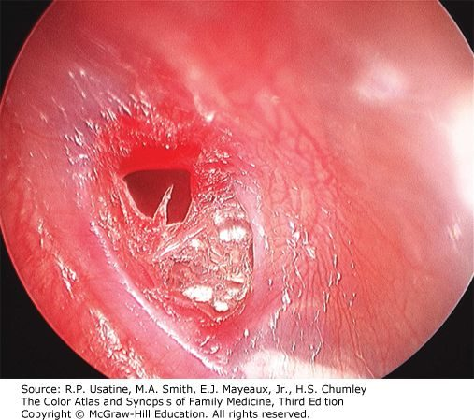
Tympanic membrane perforation Slide 47
Gives itself away by: Pain stops after the rupture · conductive loss · visible defect
Presentation & who gets itFollows impact injury, explosive acoustic trauma, barotrauma or severe acute otitis media. Symptoms vary with cause but it is generally not painful once the membrane has ruptured. Conductive hearing loss. Otoscopy distinguishes central (does not reach the margin) from marginal (involves the margin); drainage through the perforation if it followed acute otitis media.Pain / hearing loss / key findingStops once it ruptures · Conductive · Visible defect, central or marginalTesting & causeClinical, on otoscopy.First-line treatmentMost resolve spontaneously over several weeks — and as little as 48–72 hours when it followed acute otitis media. Surgical reconstruction for large perforations or ones present a long time (ENT).Education & prognosisKeep the ear dry while it heals. Report worsening hearing or dizziness — trauma can disrupt the ossicles as well.
Slides 45–47

Cholesteatoma Urgent
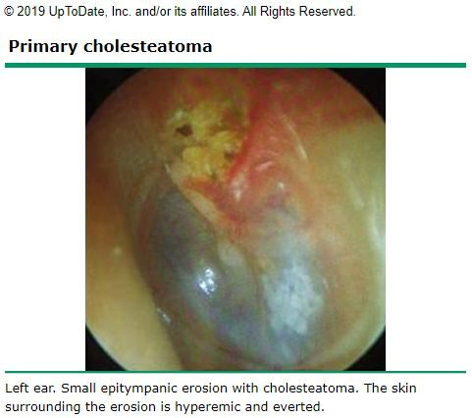
Cholesteatoma Slide 35
Gives itself away by: Keratin debris in a retraction pocket · recurrent otorrhoea with no otitis externa
Presentation & who gets itA collection of keratinised squamous epithelium in the middle ear or mastoid. No cholesterol in it and not a neoplasm, despite the name. Primary is commonest and forms from retraction of the tympanic membrane, usually the pars flaccida; secondary follows epithelial migration or surgery; congenital is least common and forms with no retraction or perforation. Risk factors are eustachian tube dysfunction and chronic middle ear inflammation. May be asymptomatic; otherwise tinnitus, recurrent otorrhoea in the absence of otitis externa, and hearing loss as a late finding.Pain / hearing loss / key findingNo — otorrhoea · Conductive, a late finding · Keratin debris in a retractionTesting & causeUsually a clinical diagnosis. Otoscopy: retraction containing squamous epithelium and keratin debris, debris behind the drum, sometimes purulent otorrhoea, granulation tissue or visible ossicular erosion. Audiometry to assess hearing loss. CT for extent in severe cases, and useful in secondary acquired disease when the drum is opaque.First-line treatmentRefer to ENT. Remove canal debris, treat infection with antibiotics, then surgical removal, usually with tympanoplasty. Mastoidectomy if it extends into the mastoid with bony erosion.Education & prognosisIt erodes bone, so it is removed rather than watched — the discharge is a symptom of that, not a simple infection.
Slides 31–37

1.6 · Conductive fixation and neoplasms

Otosclerosis Routine
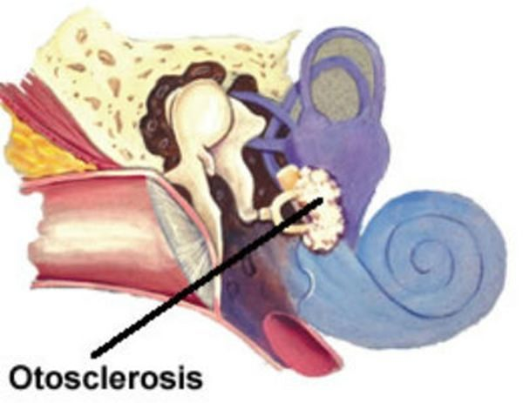
Otosclerosis Slide 65
Gives itself away by: Hearing is better in background noise · gradual conductive loss · normal drum
Presentation & who gets itBony overgrowth affecting the stapes, which eventually fixes and causes hearing loss. Gradual conductive loss, bilateral and asymmetric in 70%, unilateral in 30%. The patient reports that hearing is better with background noise. Tinnitus.Pain / hearing loss / key findingNO · Conductive, gradual · NORMAL drumTesting & causeVisual examination is normal — its job is to exclude the other causes of conductive loss such as foreign body and cerumen impaction. Weber lateralises to the affected ear (or the more affected ear if bilateral) and bone conduction is greater than or equal to air conduction on Rinne. Audiometry for the extent; CT is the initial imaging of choice. Differential: perforation, severe tympanosclerosis, otitis media with effusion, cholesteatoma, ossicular discontinuity, middle ear tumour.First-line treatmentObservation if unilateral or the patient is untroubled. Hearing aids. Surgery is elective, generally one ear at a time, replacing the stapes with a prosthesis or placing a cochlear implant (ENT). Non-surgical options under investigation — sodium fluoride, bisphosphonates — with recommendations varying widely (ENT).Education & prognosisA conductive loss with a normal-looking drum is the pattern; improved hearing in noise is the sentence patients volunteer.
Slides 65–67

Carcinoma of the ear canal Emergent
Gives itself away by: Otitis externa that will not respond to treatment · bloody otorrhoea · friable canal
Presentation & who gets itVery rare and aggressive. Presents with an abnormal growth in the ear canal, bloody otorrhoea, a friable ear canal and failure to respond to treatment for external otitis. Late findings are hearing loss and facial paralysis. Often misdiagnosed as otitis externa.Pain / hearing loss / key findingYES · Conductive, late · Friable growth, bloody otorrhoeaTesting & causeDefinitive diagnosis is biopsy.First-line treatmentBiopsy first, then oncological management (ENT).Education & prognosisThe teaching point is the misdiagnosis: an otitis externa that does not respond, especially with blood, gets looked at again rather than re-treated.
Slides 71

2 · Disorders of the Inner Ear, Balance and Hearing Loss
INSTRUCTIONAL OBJECTIVES
DISORDERS OF THE EARS, NOSE, THROAT AND NECK — Inner Ear, Balance and Hearing Loss
- Compare and contrast the etiologies, epidemiology, risk factors, clinical manifestations, differential diagnosis, diagnostic testing (including ordering and interpretation), management (acute and chronic, including applicable rehabilitative and palliative care), appropriate referrals, patient education, and prognosis of the following disorders of the inner ear, balance, and hearing loss:
- Acoustic neuroma
- Hearing impairment
- Sensorineural
- Conductive
- Tinnitus
- Ototoxicity
- Mastoiditis
- Vertebro-basilar arterial occlusion
- Labyrinthitis
- Benign paroxysmal positional vertigo
- Meniere’s disease
- Explain the difference between Weber and Rinne testing.
- Apply Weber and Rinne findings to sensorineural and conductive hearing loss.
- Explain how to interpret an audiogram and tympanogram.
- Describe vestibular testing and indications for ordering vestibular testing.
- Interpret results of vestibular testing.
- Identify medical care strategies for disorders of the inner ear, balance, and hearing loss in the lecture topic list for the following populations: 1. infant · 2. child · 3. adolescent · 4. adult

NOTE
Four of the seven objectives are about the TESTS, not a disease. Objectives b through f ask you to explain Weber against Rinne, apply their findings, read an audiogram and a tympanogram, and describe and interpret vestibular testing. That is why this section opens with them rather than with a condition.
Sort the vertigo by duration first. Seconds → benign positional vertigo. Minutes to hours → Ménière’s. Days to weeks → labyrinthitis or vestibular neuronitis, and the one word separating those two is whether hearing is affected. She called the types-of-vertigo table one to “definitely know”.

2.1 · Weber, Rinne, and reading the two tracings
NOTE
She stopped the lecture to say a question like this is on the paper. Her words: “this is what I expect you to get right on the test, because there is a test question like this.” The vignette she worked through:
A 39-year-old man is evaluated for right ear fullness and decreased hearing that developed after an upper respiratory tract infection. He denies tinnitus, vertigo, fever and ear drainage. On examination an amber effusion is visible behind an intact right tympanic membrane, which has decreased mobility. The left ear is normal. Which Weber and Rinne findings are most likely?
A right middle ear effusion is a conductive loss, so Weber lateralises to the right and Rinne becomes abnormal on the right, with bone conduction at least equal to air.
She also described the question the other way round, and it is worth writing down: “I can give you these Weber and Rinne results and you’ll automatically know if it’s conductive or sensorineural … I have things like wax impaction on there, and that would be the answer, because the other choices wouldn’t be conductive.” The distractors die on loss type before you think about anything else.

 | Weber | Rinne | Voice | In noise
Normal | No lateralisation | AC > BC | Normal | Normal
Conductive | TO the bad ear | BC ≥ AC | Soft | Better
Sensorineural | AWAY, to the good ear | AC > BC (same as normal) | Loud | Worse

NOTE
Why Weber carries the diagnosis. A sensorineural loss leaves the Rinne relationship looking exactly like a normal ear — air still beats bone. Only Weber separates them.
Audiometry severity, and she flagged this chart to know outright. It runs in twenties: normal 0–20 dB, mild 20–40, moderate 40–60, severe 60–80, profound above 80. Her own words for it: “it's all by 20s.” The prevalence percentages on the neighbouring slide are explicitly NOT to be memorised — “you don’t have to memorize these statistics”.
Tympanometry, by shape. A normal · B flat, meaning fluid or a perforation · C peak shifted negative, meaning eustachian tube dysfunction · As shallow and stiff, meaning ossicular fixation or tympanosclerosis · Ad deep and over-compliant, meaning ossicular discontinuity or a monomeric drum.
Vestibular testing. Electronystagmography is the gold standard for a disorder affecting one ear at a time; magnetic resonance imaging with gadolinium is the gold standard when retrocochlear disease is suspected; the Dix-Hallpike manoeuvre diagnoses positional vertigo and the Epley manoeuvre treats it.

2.2 · The two patterns, and presbycusis

Conductive hearing loss Routine
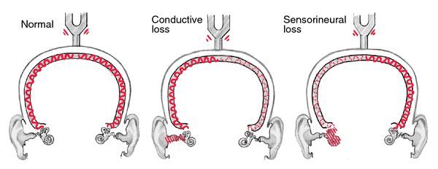
Conductive hearing loss L16 slide 39
Gives itself away by: Weber lateralises TO the bad ear · BC ≥ AC · hearing better in noise
Presentation & who gets itAn external or middle ear disorder impairing sound conduction to the inner ear. Four mechanisms: obstruction (cerumen), mass loading (effusion), stiffness (otosclerosis) and discontinuity (ossicular disruption). Onset is typically childhood to age 40. The abnormality is usually visible on otoscopy — except in otosclerosis. Hearing seems to improve in a noisy environment and the voice stays soft, because the inner ear and cochlear nerve are intact. Causes: cerumen impaction*, eustachian tube dysfunction*, otitis media, perforation, otosclerosis, foreign body, cholesteatoma, exostosis, glomus tumour, ossicular discontinuity (*commonest in adults).Pain / hearing loss / key findingDepends on the cause · Conductive · Weber TO the bad ear; BC ≥ ACTesting & causeWeber lateralises to the impaired ear. Rinne: BC = AC or BC > AC. Audiometry for the degree; tympanometry for the middle ear.First-line treatmentTreat the cause. Often correctable — which is the headline difference from sensorineural loss.Education & prognosisThe reassuring half of the pair: most conductive loss has a fixable mechanical cause.
Slides 10–11, 42

Sensorineural hearing loss Urgent
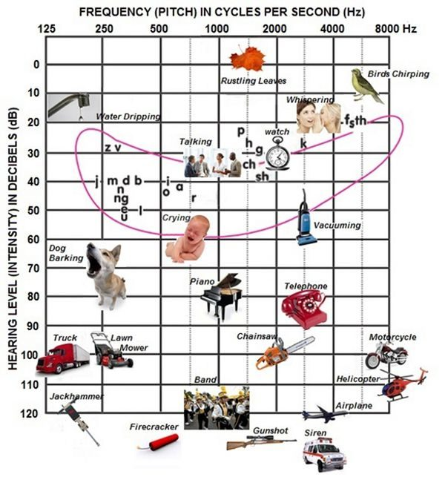
Sensorineural hearing loss L16 slide 5
Gives itself away by: Weber lateralises AWAY to the good ear · AC > BC · worse in noise
Presentation & who gets itSensory (deterioration of the cochlea and loss of hair cells) and neural (lesions of the eighth nerve, auditory nuclei, ascending tracts, auditory cortex) are difficult to separate clinically and are grouped together. Onset in middle or later years; the ear canal and drum look normal. Higher registers are lost so sound is distorted, hearing worsens in a noisy environment, and the voice may be loud because hearing is difficult.Pain / hearing loss / key findingNo · Sensorineural · Weber to the GOOD ear; AC > BCTesting & causeWeber lateralises to the GOOD ear. Rinne: AC > BC — the same as normal, which is why Weber carries the diagnosis. Audiometry classifies severity: normal 0–20 dB, mild 20–40, moderate 40–60, severe 60–80, profound >80 dB. It is all by 20s — 20, 40, 60, 80, which is how it was given in the lecture, and it is one of the few charts flagged as one to know outright.First-line treatmentUsually not correctable, but may be stabilised and some types prevented. Acute-onset sensory loss may respond to corticosteroids in the first weeks.Education & prognosisThe window for steroids in sudden loss is short, which is why new one-sided hearing loss is not a wait-and-see problem.
Slides 12–14, 42

Presbycusis Routine
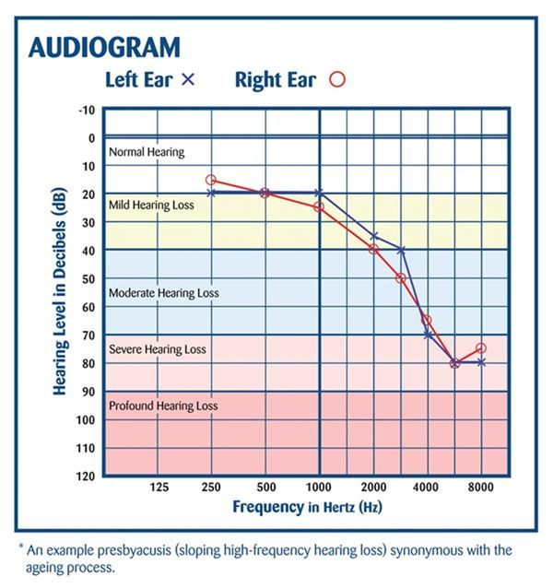
Presbycusis L16 slide 19
Gives itself away by: Hears people speak but cannot make out words · bilateral · high frequency first
Presentation & who gets itThe commonest sensorineural hearing loss. Progressive age-related loss from hair cell loss in the organ of Corti and cochlear nerve degeneration. Bilateral, symmetrical, gradual. High frequencies go first, progressing to mid and low. Patients hear speech but cannot make out the words, miss the doorbell and the phone, may have tinnitus, and lip-read more than they realise. It is common enough that primary care screens everyone aged 65 and over for it as a matter of routine. The prevalence percentages on the slide are explicitly not to be memorised — “you don’t have to memorize these statistics”.Pain / hearing loss / key findingNo · Sensorineural, bilateral · High-frequency loss, normal drumTesting & causeAudiometry showing bilateral symmetrical high-frequency loss.First-line treatmentAmplification and communication strategy. Not correctable.Education & prognosisFace the patient, do not shout — volume is not the problem, discrimination is.
Slides 15, 60–61

2.3 · Tinnitus, and the masses you can see

Tinnitus Routine
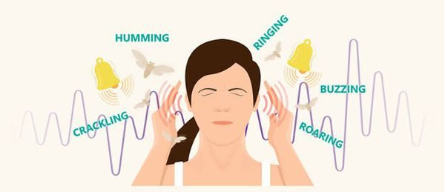
Tinnitus L16 slide 43
Gives itself away by: Ringing with no external source · RED FLAG: unilateral or pulsatile
Presentation & who gets itCan accompany any type of hearing loss and is often the first symptom of it. Described as ringing, buzzing, humming, hissing, a motor running, insects. Usually subjective; occasionally objective, meaning the examiner can hear it too. Everyone hears normal head noise in silence; low tolerance for it is associated with depression, neurosis, stress and fatigue.Pain / hearing loss / key findingNo · Any type — often the first symptom · Unilateral or pulsatile is the red flagTesting & causeClinical. RED FLAG: unilateral or pulsatile tinnitus — that pattern is investigated rather than reassured.First-line treatmentNo drug has been more effective than placebo. Biofeedback and masking noises may work.Education & prognosisAvoid loud noise, get the lead level checked, avoid stimulants, exercise daily, get adequate rest, and learn to treat the noise as an annoyance rather than a threat.
Slides 44–46

Exostosis Routine
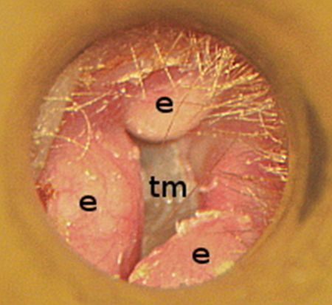
Exostosis L16 slide 49
Gives itself away by: Surfer or diver · bilaterally symmetrical bony canal growths
Presentation & who gets itBony growth in the external canal, bilaterally symmetrical, related to repetitive cold water exposure — divers and surfers. Can block the canal or collect debris.Pain / hearing loss / key findingNo · Conductive · Bilateral bony canal growthsTesting & causeOtoscopy. Causes conductive hearing loss.First-line treatmentAddress obstruction and trapped debris; surgical removal if the canal is occluded.Education & prognosisEarplugs in cold water are the prevention; the growths themselves are slow and painless.
Slides 48

Glomus tumour Urgent
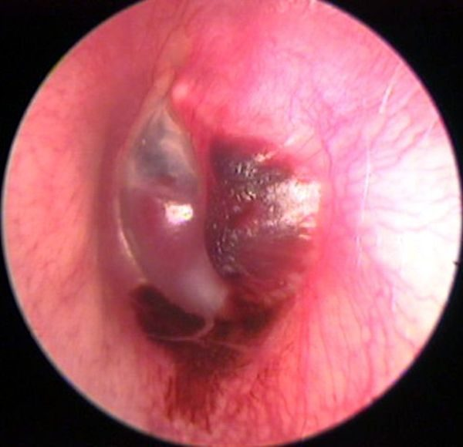
Glomus tumour L16 slide 51
Gives itself away by: Pulsatile tinnitus · vascular middle ear mass · cranial nerve IX, X, XI palsy
Presentation & who gets itBenign but highly vascular tumour derived from the normal glomus formations of the middle ear and jugular bulb. Produces a middle ear mass effect, can present with spontaneous haemorrhage and paralysis of cranial nerves IX, X and XI, and may erode the skull base.Pain / hearing loss / key findingNo · Conductive · Vascular middle ear mass; pulsatile tinnitusTesting & causeCauses conductive hearing loss and pulsatile tinnitus — the combination that separates it. Imaging for extent.First-line treatmentENT and skull base management.Education & prognosisPulsatile tinnitus with a mass behind the drum is not reassured away.
Slides 50

2.4 · Acquired sensorineural loss

Ototoxicity Urgent
Gives itself away by: Bilateral sensorineural loss on a known drug · aminoglycosides
Presentation & who gets itAminoglycosides are the most ototoxic and the most common — monitor peak levels. Also furosemide, aspirin and platinum-based chemotherapy. Many other agents have potential ototoxicity, and drugs that are ototoxic are frequently also nephrotoxic and vice versa, including the non-steroidal anti-inflammatories. Produces bilateral sensorineural hearing loss.Pain / hearing loss / key findingNo · Sensorineural, BILATERAL · Normal drum; drug historyTesting & causeHistory of exposure plus audiometry. Monitor aminoglycoside peak levels.First-line treatmentStop or change the agent where possible; the loss is often not reversible.Education & prognosisIf a drug is ototoxic, ask about the kidneys too — the two toxicities travel together.
Slides 52–53

Noise-induced hearing loss Routine
Gives itself away by: Temporary threshold shift recovering in 24–48 h · “crickets” and fullness
Presentation & who gets itOne of the most common occupationally induced disabilities; exposure is regulated by OSHA. Most acute exposures produce temporary sensorineural loss recovering in 24–48 hours — a temporary threshold shift, with the ear feeling full and “crickets”. If the level is high enough or repeated often enough the loss becomes permanent — a permanent threshold shift. Rarely, extremely intense impulse exposure perforates the drum, giving a conductive loss instead.Pain / hearing loss / key findingNo — fullness, “crickets” · Sensorineural · Normal drum; exposure historyTesting & causeAudiometry. Exposure history against the decibel table: damage is possible after 2 hours at 80–85 dB, 50 minutes at 95, 15 minutes at 100, under 5 minutes at 105–110, and pain and injury at 120.First-line treatmentRemove the exposure and protect hearing. The permanent component is not recoverable.Education & prognosisThe temporary shift is the warning shot — recovering by the next day does not mean no damage is accumulating.
Slides 54–55

Acoustic trauma Urgent
Gives itself away by: Single loud noise · immediate loss · may perforate the drum
Presentation & who gets itA single loud noise creating immediate hearing loss, and it may perforate the tympanic membrane. Blows to the head can cause labyrinthine injury with resulting sensorineural loss. Penetrating injuries are rare but usually involve subluxation of the stapes, causing profound sensorineural loss.Pain / hearing loss / key findingYES at the time · Sensorineural; conductive if perforated · May show perforationTesting & causeAudiometry. Depending on the type, the loss can mimic noise-induced loss or be a complete loss of both auditory and vestibular function.First-line treatmentSupportive; ENT for perforation or suspected ossicular injury.Education & prognosisOne event can do what years of exposure does — and a penetrating injury threatens balance as well as hearing.
Slides 56–57

Perilymphatic fistula Urgent
Gives itself away by: Audible “pop” then sudden loss and vertigo after straining or barotrauma
Presentation & who gets itA pathological communication between the perilymphatic space of the inner ear and the middle ear, at the round or oval window. Congenital or acquired. Acquired causes: barotrauma, temporal bone trauma, or a complication of stapedectomy. Presents as sudden sensorineural loss and vertigo after head injury, barotrauma, or heavy lifting and straining, sometimes with an audible “pop”. A rare cause of vertigo and sensorineural loss.Pain / hearing loss / key findingNo · Sensorineural, sudden · Audible “pop” with vertigoTesting & causeClinical, on the history. Fistula test is among the vestibular studies.First-line treatmentTreat symptomatically and refer to ENT.Education & prognosisThe trigger is the diagnosis: sudden hearing loss and vertigo that began with a strain, a dive or a blow.
Slides 63–64

Autoimmune sensorineural loss Urgent
Gives itself away by: Bilateral, progressive, in periods of deterioration and stabilisation
Presentation & who gets itSensorineural loss that is most often bilateral and progressive, with periods of deterioration and stabilisation, and may be accompanied by vestibular dysfunction. Uncommon: Cogan's syndrome, polyarteritis nodosa, relapsing polychondritis, granulomatosis with polyangiitis. Even less common: scleroderma, temporal arteritis, systemic lupus erythematosus, sarcoidosis.Pain / hearing loss / key findingNo · Sensorineural, bilateral · Stepwise deteriorationTesting & causeRoutine screening for autoimmune disorders is not warranted — test when the picture suggests it.First-line treatmentTreat the underlying disease.Education & prognosisThe stepwise pattern — worse, then stable, then worse — is what distinguishes it from a steady decline.
Slides 65–66

Syphilitic sensorineural loss Urgent
Gives itself away by: Indistinguishable from Ménière's · the treatable cause you must not miss
Presentation & who gets itCongenital or acquired. Hearing loss is not associated with primary acquired syphilis, but reaches as high as 80% in symptomatic neurosyphilis. Presentation is often indistinguishable from Ménière's: fluctuating sensorineural loss, tinnitus, aural fullness and episodic vertigo.Pain / hearing loss / key findingNo · Sensorineural, fluctuating · Mimics Ménière'sTesting & causeThe one exception to not ordering labs. FTA-ABS and MHA-TP should be obtained. VDRL is not helpful.First-line treatmentAntibiotic with the addition of systemic corticosteroids.Education & prognosisIt is tested for precisely because it is a potentially treatable cause of sensorineural loss hiding behind a Ménière's picture.
Slides 35, 68

AIDS-related sensorineural loss Urgent
Gives itself away by: Unexplained sensorineural loss with risk factors present
Presentation & who gets itSensorineural loss is among the numerous neurological manifestations of AIDS. It may come from an infectious complication — cryptococcal meningitis or syphilis — or be a primary neurological manifestation.Pain / hearing loss / key findingNo · Sensorineural · Unexplained loss with risk factorsTesting & causeConsider in any patient with unexplained sensorineural loss and risk factors present.First-line treatmentTreat the underlying cause.Education & prognosisIt is on the list so that unexplained loss prompts a risk-factor history rather than an audiogram alone.
Slides 67

Hereditary sensorineural loss Routine
Gives itself away by: Waardenburg, Alport, Usher · and the nonsyndromic majority
Presentation & who gets itNonsyndromic hereditary hearing loss, plus the named syndromes: Waardenburg's, Alport and Usher's.Pain / hearing loss / key findingNo · Sensorineural · Family history; syndromic featuresTesting & causeFamily history; genetic evaluation where indicated.First-line treatmentAmplification and the associated systemic disease.Education & prognosisThe syndromic names carry the other organ involved — kidney in Alport, vision in Usher.
Slides 71

Sudden sensorineural hearing loss Emergent
Gives itself away by: Unilateral, sudden · a syndrome, not a disease · prompt ENT referral
Presentation & who gets itUnilateral. Described explicitly as a syndrome, not a disease. Viral or vascular aetiology; rarely retrocochlear pathology — horses not zebras. The exact cause is rarely certain.Pain / hearing loss / key findingNo · Sensorineural, UNILATERAL · Normal drum, sudden onsetTesting & causeAudiometry to confirm and side it. Imaging only in selected patients.First-line treatmentDemands prompt referral to ENT. Acute sensory loss may respond to corticosteroids within the first weeks.Education & prognosisSpeed is the whole management. This is the one hearing complaint that is seen the same day.
Slides 13, 79

2.5 · The inner ear syndromes — sorted by how long the vertigo lasts

Benign paroxysmal positional vertigo Routine
Gives itself away by: Seconds of vertigo on rolling over · hearing normal, no tinnitus
Presentation & who gets itSevere vertigo with change in head position — rolling over, getting into bed, standing up, bending, looking up to reach an object, tilting the head back to shave, a haircut, turning rapidly. A specific side is typically described. Symptoms come on after a short latency of 10–15 seconds and last only 10–60 seconds; more than a minute should prompt an alternative diagnosis. Bouts cluster in time with remissions of months or more. Between attacks there may be constant lightheadedness worse with head movement, and imbalance for hours after an episode.Pain / hearing loss / key findingNo · NOT affected · Positive Dix-Hallpike; seconds onlyTesting & causeDiagnosed by the classic eye movements on the Dix-Hallpike manoeuvre plus a suggestive history. Most cases have no identifiable aetiology; canalithiasis of the posterior semicircular canal is thought to be the commonest cause.First-line treatmentThe Epley manoeuvre, which repositions the otoliths in the semicircular canal.Education & prognosisHearing is not affected and there is no tinnitus — those two absences are what place it against Ménière's.
Slides 89–93, 97

Ménière's disease Urgent
Gives itself away by: Vertigo hours long · LOW-frequency fluctuating loss · fullness and low-tone tinnitus
Presentation & who gets itFluctuating LOW-frequency sensorineural hearing loss that may fluctuate at first then progress. Low-tone, “blowing” tinnitus. Unilateral fullness in the ear. Episodes of vertigo, often the presenting complaint. Typical attack: episodic, spontaneous, severe spinning vertigo lasting several hours, frequently with nausea, vomiting and diaphoresis.Pain / hearing loss / key findingNo — fullness · Sensorineural, LOW frequency, fluctuating · Vertigo lasting hours + tinnitusTesting & causeClinical. Duration separates it: seconds for benign positional vertigo, minutes to hours for Ménière's, days to weeks for vestibular neuronitis and labyrinthitis. Rule out syphilis, which mimics it exactly.First-line treatmentSymptomatic control of the attacks and the underlying management.Education & prognosisThe tetrad is vertigo, fluctuating hearing loss, tinnitus and fullness — and unlike the other peripheral causes, hearing is affected.
Slides 69–70, 89, 97

Labyrinthitis Urgent
Gives itself away by: Sudden vertigo WITH hearing loss lasting days to weeks
Presentation & who gets itInflammation of the membranous labyrinth of the inner ear. Relatively sudden onset of sensorineural hearing loss AND acute vertigo. Exact aetiology rarely certain; evidence supports a viral cause, and it may be associated with bacterial infection or systemic autoimmune disease. Also listed as a complication of acute otitis media.Pain / hearing loss / key findingNo · Sensorineural — hearing IS affected · Sudden vertigo, days to weeksTesting & causeClinical. Duration several days to weeks.First-line treatmentSymptomatic. Antibiotics if bacterial symptoms such as fever are present. Oral corticosteroids. Oral diazepam or meclizine during the acute vertigo.Education & prognosisThe difference from vestibular neuronitis is one word: labyrinthitis affects hearing.
Slides 95, 97

Vestibular neuronitis Urgent
Gives itself away by: Dramatic sudden vertigo with NO hearing change · benign and self-limiting
Presentation & who gets itInflammation of the vestibular portion of cranial nerve VIII, likely viral though the cause is unknown. Considered benign and self-limiting. Dramatic, sudden vertigo with nausea and gait imbalance. Dizziness lasts days with gradual improvement; balance symptoms may persist for months. Not associated with any change in hearing or focal neurological complaints.Pain / hearing loss / key findingNo · NOT affected · Sudden vertigo, no hearing changeTesting & causeClinical diagnosis.First-line treatmentSymptomatic. Oral diazepam or meclizine during the acute phase, antiemetics, and oral corticosteroids are questioned in the deck rather than asserted.Education & prognosisNormal hearing and no focal neurology is what makes it benign — either of those being abnormal moves the diagnosis.
Slides 96–97

2.6 · Retrocochlear, central, and not-organic

Acoustic neuroma Urgent
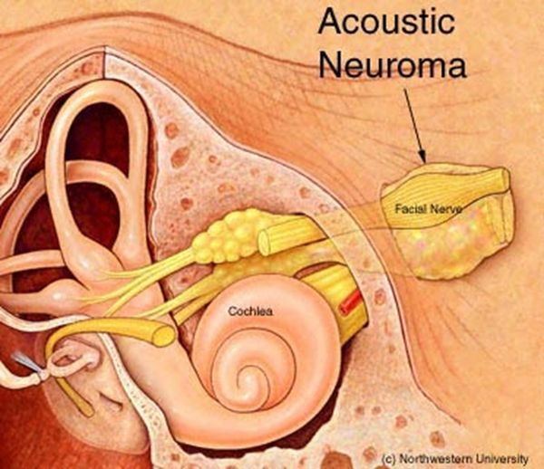
Acoustic neuroma L16 slide 73
Gives itself away by: Unilateral loss with speech discrimination worse than the tone loss predicts
Presentation & who gets itBenign tumour of cranial nerve VIII, rare, and most often unilateral. Symptoms: unilateral hearing loss, which may be sudden; poor speech discrimination compared with what the tone loss would predict; often disequilibrium. Progression may not be so “benign”. May involve cranial nerves V and VII.Pain / hearing loss / key findingNo · Sensorineural, unilateral · Speech discrimination worse than expectedTesting & causeMRI with gadolinium is the gold standard for evaluating potential retrocochlear loss. Electronystagmography is the gold standard vestibular test for disorders affecting one ear at a time. Radiographic imaging is warranted in selected patients with sensorineural loss.First-line treatmentObservation with annual MRI, surgery, or radiation.Education & prognosisThe discriminating symptom is not the volume of the loss but the disproportionately poor word understanding on the affected side.
Slides 72–75, 97

Vertebrobasilar insufficiency or occlusion Emergent
Gives itself away by: Vertigo in an elderly patient with brainstem signs
Presentation & who gets itA common cause of vertigo in elderly patients. Occlusion may be thrombotic or embolic. Symptoms: acute vertigo, nausea and vomiting, facial paralysis, tinnitus, ipsilateral gaze paralysis, ipsilateral loss of pain and temperature on the face, contralateral partial loss of pain and temperature on the trunk and limbs, and ipsilateral Horner's syndrome. Vascular disease is the commonest non-vestibular cause of dizziness and balance loss in the elderly.Pain / hearing loss / key findingNo · May be affected · Brainstem signs with the vertigoTesting & causeMagnetic resonance angiography, which also shows small vessel disease as scattered small white lesions. Carotid dopplers.First-line treatmentVascular and stroke management.Education & prognosisVertigo with any crossed sensory finding, facial weakness or gaze palsy is a brainstem problem until proven otherwise.
Slides 77, 85–87

Isolated cerebellar infarction Emergent
Gives itself away by: Vertigo with ataxia, headache or facial numbness
Presentation & who gets itSymptoms include vertigo, facial pain or numbness, headache, or ataxia. The deck's instruction is explicit: “Don't miss something bigger than the hearing loss” — look for signs of a more sinister acute problem.Pain / hearing loss / key findingHeadache possible · Not affected · Ataxia, facial numbnessTesting & causeNeuroimaging.First-line treatmentRefer for evaluation.Education & prognosisIt is in a hearing lecture as a warning, not as an ear disease.
Slides 78

Functional hearing loss Routine
Gives itself away by: Claims profound bilateral loss but the voice is normal
Presentation & who gets itSuspected when the history contains inconsistencies, complaints and exaggerated listening effort. The patient's voice and speech quality provide important information: someone claiming significant bilateral loss while speaking at a normal level with normal articulation should be suspected of functional behaviour.Pain / hearing loss / key findingNo · Claimed, not organic · Normal voice despite claimed lossTesting & causeThe mismatch between claimed loss and the voice is the finding. Audiometry with cross-checks.First-line treatmentAddress the underlying reason rather than the audiogram.Education & prognosisA genuinely deaf voice changes. That is the observation the diagnosis rests on.
Slides 80

3 · Disorders of the Nose and Paranasal Sinuses
INSTRUCTIONAL OBJECTIVES
DISORDERS OF THE EARS, NOSE, THROAT AND NECK — Nose and Paranasal Sinuses
- Compare and contrast the etiologies, epidemiology, risk factors, clinical manifestations, differential diagnosis, diagnostic testing (including ordering and interpretation), management (acute and chronic, including applicable rehabilitative and palliative care), appropriate referrals, patient education, and prognosis of the following disorders of the nose and paranasal sinuses:
- Acute and chronic sinusitis
- Nasal trauma
- Deviated septum
- Perforated septum
- Septal hematoma
- Nasal fracture
- Epistaxis
- Nasal foreign body
- Nasal polyp
- Rhinitis: i. Allergic · ii. Vasomotor
- Neoplasms: i. Benign · ii. Malignant
- Identify medical care strategies for disorders of the nose and paranasal sinuses in the lecture topic list for the following populations: 1. adolescent · 2. adult · 3. elderly

NOTE
The whole first half of this lecture is one decision: is it viral or bacterial? 90–98% of acute rhinosinusitis is viral, and only 0.5–2% of those develop a bacterial superinfection — yet it is the fifth leading reason antibiotics get prescribed. The features that shift you toward bacterial are:
- Double worsening — getting worse again more than 5–6 days after initially improving
- Persistent symptoms for 10 days or more
- Persistent purulent discharge
- UNILATERAL upper tooth or facial pain, or unilateral maxillary tenderness
- Fever, or altered mental status
Pain is the big distinguishing factor — it occurs only in bacterial and fungal sinusitis, and it is reproducible on palpation, which a common cold is not.
And no test settles it. Nothing distinguishes viral from bacterial, routine sinus radiography is discouraged, and three or more clinical findings have similar accuracy to imaging anyway. CT is for recurrent disease, treatment failure, or suspected extrasinus involvement.

NOTE
His second emphasis marker: the yellow highlight. Talking through the epidemiology he said — “maybe it’s highlighted in yellow and I’m trying to make a specific point about this, maybe like in the last lecture when something was highlighted in yellow and I said it was important to remember” — and then walked the class to the answer he wanted: the commonest pathogen in otitis media is viral, and so is the commonest pathogen in sinusitis. When a slide of his has something highlighted in yellow, that is deliberate. It sits alongside his other marker, saying a thing three times.
He called acute sinusitis “one of your bread-and-butter diagnoses … something you’re going to see all the time, especially in primary care”, and was blunt about the reflex to treat: “everybody says oh no it’s bacterial and everybody’s going to go home with a course of antibiotics — is that the right thing to do? No, of course not. We have to be good stewards of our antibiotics.”

NOTE
Discharge colour is the thing patients trust most and the thing that helps least. Yellow or green is explicitly the least useful. Clear may be viral or allergic. Yellow and putrid suggests bacterial. Black suggests fungus. Rust-coloured may be S. pneumoniae.
Allergy does not cause an “-itis”. It creates the perfect environment for infection. Many patients who believe they have sinusitis have allergic disease.
One objective has no slide. The syllabus lists rhinitis as allergic and vasomotor; the deck covers allergic rhinitis in full and never mentions vasomotor rhinitis. It is flagged here rather than quietly omitted — it is a named objective with no lecture content behind it.

3.1 · Sinusitis, acute through chronic

Acute sinusitis (rhinosinusitis) Routine
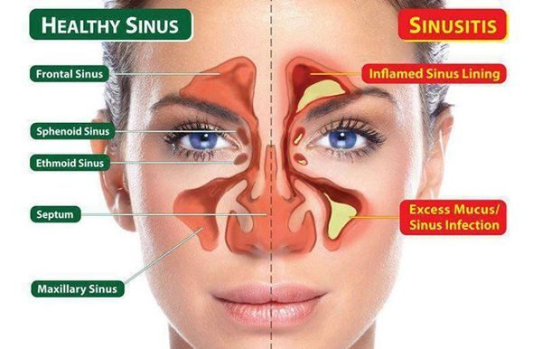
Acute sinusitis (rhinosinusitis) L17 slide 7
Gives itself away by: Under 4 weeks · 90–98% VIRAL · facial pain that is worse bending forward
Presentation & who gets itSymptomatic inflammation of one or more paranasal sinuses lasting under four weeks, from impaired drainage and retained secretions, with obstruction and/or facial pain, pressure or fullness. “Rhinosinusitis” is the preferred term because rhinitis and sinusitis usually coexist. Affects 1 in 8 adults — over 30 million a year in the United States — and is the fifth leading reason antibiotics are prescribed. Nasal drainage and congestion, rhinorrhoea, postnasal drip, headache. Pain localises to the involved sinus and is worse bending over or lying flat.Pain / discharge / key findingPressure; frank pain suggests bacterial · Rhinorrhoea, postnasal drip · Pain worse bending forwardTesting & causeNo diagnostic test distinguishes viral from bacterial, and none is indicated routinely. Routine sinus radiography is discouraged: three or more clinical findings have similar accuracy to imaging, and imaging cannot separate the two causes anyway. Limited coronal CT for recurrent infection or failure to respond, or if signs suggest extrasinus involvement. Viral causes rhinovirus, parainfluenza, influenza; bacterial S. pneumoniae, nontypable H. influenzae and — in children — M. catarrhalis. Immunocompromised: fungal — Rhizopus, Mucor, occasionally Aspergillus. Nosocomial cases are polymicrobial with S. aureus and gram-negative bacilli.First-line treatmentMost improve WITHOUT antibiotics. Symptomatic: decongestants, non-steroidal anti-inflammatories, nasal or sinus lavage, intranasal steroids, neti pot, saline sprays. If bacterial: amoxicillin/clavulanate. Penicillin allergy: doxycycline, or an antipneumococcal fluoroquinolone such as moxifloxacin. If influenza, oseltamivir for five days in anyone over 13. Medical treatment fails → ENT referral for surgery.Education & prognosisTell the patient what they have, how they got it, how to use the medicine or device, and — if referring — to which specialty. Most cases are viral and settle without antibiotics.
Slides 9–27

Bacterial sinusitis — the features that suggest it Routine
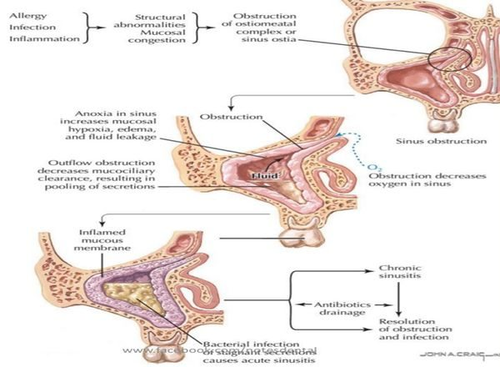
Bacterial sinusitis — the features that suggest it L17 slide 15
Gives itself away by: Double worsening · ≥10 days · UNILATERAL tooth or facial pain
Presentation & who gets itOnly 0.5–2% of viral episodes develop a bacterial superinfection, so these features are what raise the possibility: worsening after 5–6 days of initial improvement; persistent symptoms for 10 days or more; persistent purulent discharge; UNILATERAL upper tooth or facial pain; unilateral maxillary tenderness; fever; altered mental status.Pain / discharge / key findingYES — and REPRODUCIBLE on palpation · Purulent, sometimes putrid · UNILATERAL maxillary tendernessTesting & causePAIN is the big distinguishing factor — it occurs only in bacterial and fungal sinusitis, and it is reproducible on palpation, which a common cold is not. Fever above 100.4°F and severe pain point bacterial or fungal — check the patient is not on an antipyretic first. Discharge colour is largely unhelpful: yellow or green is the least useful; clear may be viral or allergic; yellow AND putrid suggests bacterial; BLACK suggests fungus; rust-coloured may be S. pneumoniae.First-line treatmentSymptomatic treatment plus antibiotics — amoxicillin/clavulanate first line.Education & prognosisThe colour of the discharge is the thing patients most expect to be diagnostic, and it is the thing that matters least.
Slides 16–19, 23

Sinusitis with urgent features Emergent
Gives itself away by: Diplopia · periorbital swelling or erythema · altered mental status
Presentation & who gets itThe lecture names these separately as symptoms requiring urgent attention in a patient with sinusitis: visual disturbance, especially diplopia; periorbital swelling or erythema; altered mental status.Pain / discharge / key findingYES · Any · Diplopia, periorbital swelling, confusionTesting & causeSinus CT if signs suggest extrasinus involvement. These are the findings that say the disease has left the sinus.First-line treatmentUrgent evaluation and imaging rather than another course of symptomatic treatment.Education & prognosisThe orbit sits next door to the ethmoid sinus. Eye signs in a sinusitis patient are the ones that change the plan.
Slides 17, 21

Chronic bacterial sinusitis Urgent
Gives itself away by: Over 12 weeks · constant congestion with flares · impaired mucociliary clearance
Presentation & who gets itSinusitis lasting more than twelve weeks. The mechanism is impaired mucociliary clearance causing REPEATED infections rather than one persistent infection. Constant nasal congestion and sinus pressure, with periods of increased severity.Pain / discharge / key findingPressure, with flares · Constant congestion · >12 weeksTesting & causeSinus CT defines extent, detects an underlying anatomic defect or obstruction, and assesses response. Endoscopy-derived tissue for histology and culture should guide treatment. Consider full blood count with differential and IgE.First-line treatmentRepeated antibiotic courses, often 3–4 weeks at a time — oral steroids plus two weeks of amoxicillin/clavulanate is the stated regimen. Adjuncts: intranasal glucocorticoids, sinus irrigation. Refer to ENT for surgical evaluation and to allergy for skin testing.Education & prognosisIt is a drainage problem as much as an infection, which is why it keeps coming back and why surgery enters the conversation.
Slides 28–29

Chronic fungal sinusitis Urgent
Gives itself away by: Aspergillus · a fungus ball · allergic form has peanut-butter mucus
Presentation & who gets itNoninvasive disease in immunocompetent hosts, typically Aspergillus and dematiaceous moulds. Recurrence is common. The allergic form is seen in patients with nasal polyps and asthma and presents as pansinusitis with thick, eosinophil-laden mucus the consistency of peanut butter.Pain / discharge / key findingVariable · Peanut-butter mucus in the allergic form · Fungus ball on imagingTesting & causeImaging and endoscopy. Unilateral disease with a mycetoma (fungus ball) is the characteristic finding.First-line treatmentMild indolent disease is cured by endoscopic surgery WITHOUT antifungals. A fungus ball is treated surgically — and with antifungals only if bony erosion has occurred.Education & prognosisThe surprise here is that most of it is treated surgically rather than with drugs.
Slides 30

3.2 · The septum

Deviated septum Routine
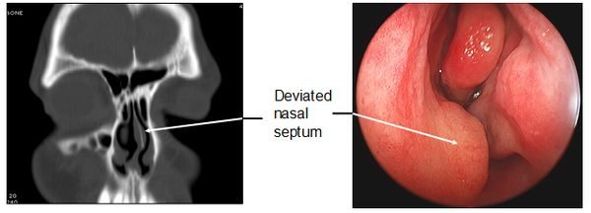
Deviated septum L17 slide 36
Gives itself away by: One passage smaller than the other · congenital or traumatic
Presentation & who gets itThe nasal septum is significantly displaced to one side, making one air passage smaller. Congenital or traumatic. Ranges from congestion — through blockage of the ostia — to anosmia. In severe forms: obstructive sleep apnoea, snoring, facial pain and recurrent nosebleeds.Pain / discharge / key findingNo, unless severe · Congestion; recurrent bleeds · One passage smallerTesting & causeClinical, with a nasal speculum; CT where needed.First-line treatmentSurgery — septoplasty, by an otorhinolaryngologist.Education & prognosisThe recurrent nosebleeds and the snoring are what usually bring the patient in, not the deviation itself.
Slides 32–36

Perforated septum Routine
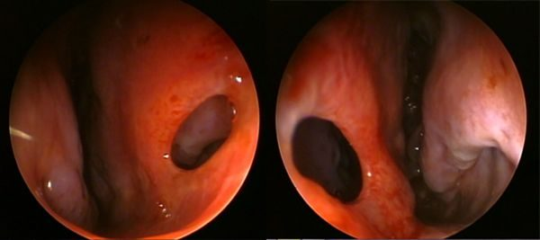
Perforated septum L17 slide 38
Gives itself away by: Intranasal steroid or COCAINE use · chronic ischaemia
Presentation & who gets itA perforation through the nasal septum. Congenital or traumatic, but many are from intranasal steroid use or cocaine use, both by chronic ischaemia. Rarely granulomatosis with polyangiitis (Wegener’s), a vascular autoimmune disease, may cause nasal deformity. Rarely, secondary syphilis — seldom seen now.Pain / discharge / key findingNo · Crusting, whistling · Visible perforationTesting & causePhysical examination, possibly with CT.First-line treatmentTreat the underlying cause and it may grow back; otherwise septoplasty.Education & prognosisThe drug history is the diagnosis here — ask about both prescribed nasal steroids and cocaine.
Slides 37–40

Septal haematoma Urgent
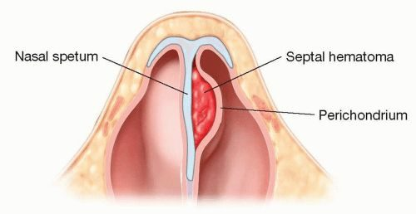
Septal haematoma L17 slide 42
Gives itself away by: Blood between septum and perichondrium · after trauma · drain it
Presentation & who gets itA haematoma between the nasal septum and the perichondrium or mucosal epithelium. Usually secondary to trauma; other causes are bleeding disorders, cocaine, foreign body and medications. Associated with nasal fracture — look for it in every nasal injury.Pain / discharge / key findingYES · Obstruction · Swelling between septum and perichondriumTesting & causeInspection with a nasal speculum. It is one of the four things that must be excluded before a nasal fracture can be managed without imaging.First-line treatmentDrainage via intranasal incision under general anaesthesia.Education & prognosisThe same lesson as the auricular haematoma in Lecture 15: cartilage separated from its blood supply does not survive.
Slides 41–43

3.3 · Epistaxis

Epistaxis — anterior Urgent
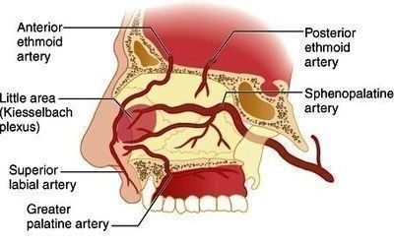
Epistaxis — anterior L17 slide 47
Gives itself away by: Kiesselbach’s plexus · 90% of nosebleeds · commonest cause is the patient’s finger
Presentation & who gets itA common emergency department complaint, most cases before age 10 or between 45 and 65, with a winter predominance. The commonest cause is trauma — from the patient’s finger. Chronic dry nose is a risk factor. Anterior bleeds are by far the commonest: 90% arise in the vascular watershed of the nasal septum — Kiesselbach’s plexus.Pain / discharge / key findingNo · Frank blood, anteriorly · Kiesselbach’s plexusTesting & causeAirway, breathing, circulation first — bleeding can be severe. Normal appearance, vital signs and respiratory function is the reassuring picture. History: tumours, coagulation disorders personal and family, recent trauma or surgery, medications — aspirin, warfarin, clopidogrel, intranasal glucocorticoids, and cirrhosis, HIV or intranasal cocaine. A prothrombin time with INR is NOT a routine test — order it for the anticoagulated patient. Haematocrit and type and crossmatch in massive or prolonged haemorrhage, with two large-bore intravenous lines.First-line treatmentInitial tamponade, and patients can do it themselves: blow the nose to clear clots → spray with oxymetazoline → pinch the alae against the septum continuously for 10 minutes. Also: sit up and lean forward at the waist so blood is not swallowed, a cotton pledget in the nostril, spit out blood in the pharynx, cold compress on the bridge. Then nasal tampons, gauze packing, balloon catheters, thrombogenic foams and gels.Education & prognosisTeach these manoeuvres for use at home. And DO NOT BLOW THE NOSE afterwards.
Slides 45–51

Epistaxis — posterior Emergent
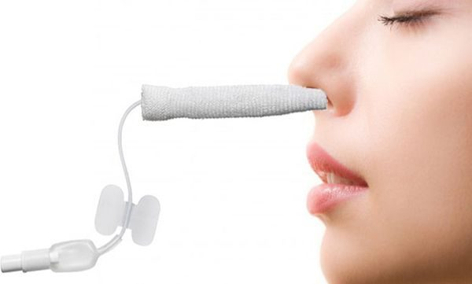
Epistaxis — posterior L17 slide 52
Gives itself away by: Sphenopalatine artery · significant haemorrhage · ASPIRATION risk
Presentation & who gets itArises most commonly from the posterolateral branches of the sphenopalatine artery, but may arise from branches of the carotid. Results in significant haemorrhage.Pain / discharge / key findingNo · Heavy; blood in the pharynx · Sphenopalatine arteryTesting & causeYou must determine whether the bleed is anterior, posterior, or both.First-line treatmentAs for anterior bleeding, escalating to packing and ENT involvement.Education & prognosisPosterior bleeds carry a higher risk because of ASPIRATION and subsequent infection — that is why the distinction is made.
Slides 45–46

3.4 · Trauma and foreign bodies

Nasal fracture Urgent
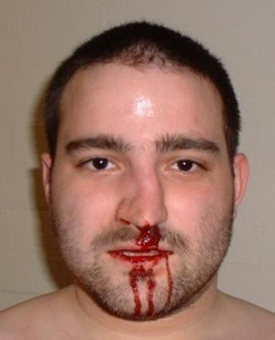
Nasal fracture L17 slide 58
Gives itself away by: Contusion and tenderness over the bridge = fracture · commonest facial fracture site
Presentation & who gets itFrom trauma. Suspect other injuries — orbital and midface fractures. Associated with septal haematoma. The nasal bridge is the commonest site. Examination: palpate for tenderness, crepitus and abnormal movement, and inspect with a nasal speculum.Pain / discharge / key findingYES · Epistaxis · Tenderness and crepitus over the bridgeTesting & causeX-rays are NOT needed if all four hold: tenderness and swelling isolated to the bony bridge; the patient can breathe through each naris; the nose is straight, with no septal deviation; and there is no septal haematoma. If any fails, plain films.First-line treatmentInitial treatment is ice and head of bed elevated.Education & prognosisThe four criteria are the useful thing to carry — they decide imaging at the bedside.
Slides 56–58

Nasal foreign body Urgent
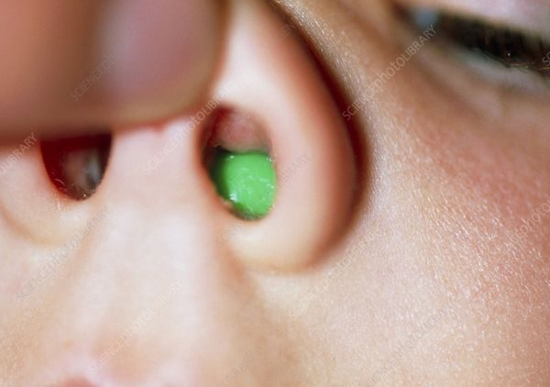
Nasal foreign body L17 slide 53
Gives itself away by: UNILATERAL foul-smelling purulent discharge in a young child
Presentation & who gets itCommonest in young children. Most often on the floor of the nasal passage just under the inferior turbinate, or superiorly just in front of the middle turbinate. Unilateral purulent and foul-smelling nasal discharge in a young child strongly suggests it.Pain / discharge / key findingVariable · UNILATERAL, purulent, FOUL-SMELLING · Object visible under a turbinateTesting & causeVisualisation establishes the diagnosis. Imaging is rarely needed.First-line treatmentRemoval — instrument chosen by what the object is: forceps for graspable objects, a wire loop, right-angle hook or curette for round smooth ones, suction for smooth or free-floating beads, beans, magnets or batteries. Get help — refer to ENT.Education & prognosisA one-sided smelly discharge in a toddler is a foreign body until proven otherwise, not sinusitis.
Slides 53–55

3.5 · Polyps and rhinitis

Nasal polyps Urgent
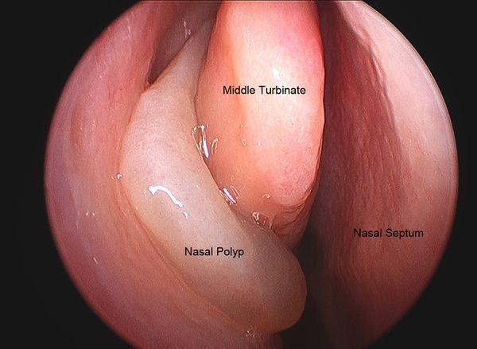
Nasal polyps L17 slide 61
Gives itself away by: Grey, glistening masses · anosmia · asthma and aspirin sensitivity
Presentation & who gets itAbnormal, grey, glistening masses filled with inflammatory material in the nasal cavity or paranasal sinuses. Large or extensive polyps cause congestion or blockage, thick discharge and ANOSMIA. Frequently associated with chronic rhinosinusitis, asthma and aspirin sensitivity — aspirin-exacerbated respiratory disease. In children they occur with chronic sinusitis, allergic rhinitis, cystic fibrosis or allergic fungal sinusitis. From the slide that is an image of a list: associated conditions include bronchial asthma 20–50%, cystic fibrosis 5–44%, allergic fungal sinusitis 85%, aspirin intolerance 8–20%, alcohol intolerance 50%, Churg-Strauss 50%, primary ciliary dyskinesia, Young syndrome and NARES 20%.Pain / discharge / key findingNo · Thick discharge · Grey glistening masses; ANOSMIATesting & causeDiagnosed clinically by their appearance on nasal speculum or rhinoscopy, and identifiable on CT. Chloride sweat test if cystic fibrosis is a concern; full blood count with differential, IgE and IgA; consider a nasal smear for eosinophils; CT for extent or surgical planning.First-line treatmentMedical: non-drowsy oral antihistamine (loratadine, fexofenadine, cetirizine, levocetirizine), leukotriene inhibitor at night (montelukast, zafirlukast), intranasal or oral steroids, intranasal ipratropium, immunotherapy, decongestants with caution. Surgery gives only temporary relief — they recur within months to years.Education & prognosisEvaluate EVERY child with benign multiple nasal polyposis for cystic fibrosis and asthma. The deck gives that its own slide.
Slides 59–65

Allergic rhinitis Routine
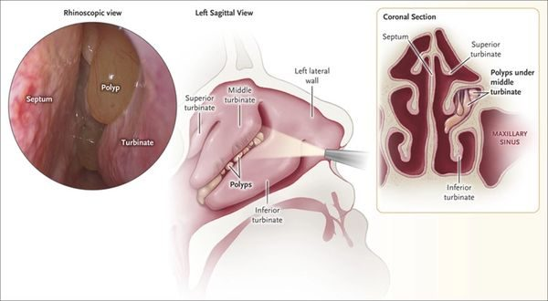
Allergic rhinitis L17 slide 62
Gives itself away by: CLEAR discharge from BOTH nostrils · bluish, boggy mucosa
Presentation & who gets itRhinorrhoea secondary to allergy: the body treats the allergen as foreign and releases chemokines causing hypermucosal production. Extremely common and rising.Pain / discharge / key findingNo · CLEAR, BILATERAL · Bluish, boggy mucosaTesting & causeClinical — mostly the history. Findings: clear discharge from each nostril, a bluish hue to the nasal mucosa, oedematous mucosa, and with or without nasal polyps.First-line treatment80% of patients end up on two or more allergy medicines. Non-drowsy oral antihistamine by day and a drowsy one at night if needed; leukotriene inhibitor at night; intranasal steroids with caution in chronic use; immunotherapy; intranasal ipratropium; decongestants with caution in chronic use and in high blood pressure.Education & prognosisAllergy does not cause “-itis” itself — it creates the perfect environment for infection. Many patients who think they have sinusitis have allergic disease.
Slides 13, 26, 66–68

3.6 · Neoplasms

Nasopharyngeal carcinoma Emergent
Gives itself away by: Neck mass + diplopia + facial numbness · Epstein-Barr virus
Presentation & who gets itThe predominant tumour arising in the nasopharynx. Rare in the United States and Western Europe; endemic in Southern China including Hong Kong, Southeast Asia, North Africa, the Middle East and the Arctic. Two- to threefold more common in males. Associated with Epstein-Barr virus, human papillomavirus and smoking, and with high-salt diets, Chinese herbs, rancid butter and sheep fat.Pain / discharge / key findingHeadache · May be bloody · Neck mass + cranial nerve signsTesting & causePresents with headache, diplopia, facial numbness and a mass in the neck. Referral to ENT and endoscopic guided biopsy of the primary tumour.First-line treatmentOncological management following biopsy (ENT).Education & prognosisThe combination that should prompt referral is a neck mass with cranial nerve symptoms, not nasal symptoms alone.
Slides 69–70

Benign nasal neoplasms Routine
Gives itself away by: Same as skin — the dermatology lesions, on the nose
Presentation & who gets itThe lecture defers to the dermatology block: warts, freckles, haemangioma, port-wine stain and the rest behave on the nose as they do elsewhere.Pain / discharge / key findingNo · None · As the equivalent skin lesionTesting & causeAs for the equivalent skin lesion.First-line treatmentAs for the equivalent skin lesion — see the dermatology lectures.Education & prognosisWorth knowing only as the counterpart to the malignant list; the detail lives in the dermatology material.
Slides 71

4 · Neoplasms and Neck Masses
INSTRUCTIONAL OBJECTIVES
DISORDERS OF THE EARS, NOSE, THROAT AND NECK — Neck Masses and Neoplasms
- Define the major and minor triangles of the neck
- Identify the lymph nodes of the neck area
- Compare and contrast the etiologies, epidemiology, risk factors, clinical manifestations, differential diagnosis, diagnostic testing (including ordering and interpretation), management (acute and chronic, including applicable rehabilitative and palliative care), appropriate referrals, patient education, and prognosis of the following neck masses and neoplasms:
- Common neck masses.
- Vascular tumors seen in the neck.
- Benign neoplasms of the neck
- Malignant neoplasms
- Primary
- Secondary
- Identify medical care strategies for disorders of the neoplasms and neck masses in the lecture topic list for the following populations: 1. adolescent · 2. adult · 3. elderly

NOTE
This lecture has no recording. Everything below comes from the slides. Where sections 1 to 3 also carry a point their lecturer made out loud, this one carries only what is written.

4.1 · The triangles and the nodes
The first two objectives are pure anatomy, and no disease row carries them, so they go first.
The neck is bounded by the mandible above and the clavicle below, and the sternocleidomastoid divides it into an anterior and a posterior triangle. Each is then subdivided by the omohyoid and digastric muscles.
Triangle | Boundaries | What is in it
Occipital | Upper part of the posterior triangle | Floor from above down: semispinalis capitis, splenius capitis, levator scapulae, scalenus medius. The spinal accessory nerve crosses the floor to pass deep to trapezius; the cutaneous nerves of the neck run in the deep fascia over it.
Supraclavicular | Above the middle of the clavicle | Terminal subclavian artery; roots, trunks and divisions of the brachial plexus; thyrocervical trunk branches; tributaries of the external jugular vein. The cupola of the pleural cavity lies deep to its contents.
Submental | Anterior belly of digastric, midline, hyoid bone | Floor formed by mylohyoid.
Digastric (submandibular) | Mandible above, the two bellies of digastric | Stylohyoid, mylohyoid and hyoglossus muscles; submandibular gland; hypoglossal nerve; facial vessels.
Carotid | Sternocleidomastoid behind, posterior belly of digastric above, omohyoid below | Carotid arteries, internal jugular vein, vagus nerve.
Muscular | Omohyoid above, sternocleidomastoid below, midline in front | Thyroid, parathyroid, larynx, trachea, oesophagus, thyroid and cricoid cartilage.

Lymphatic drainage. Superficial nodes are named for where they sit. Occipital, retroauricular and parotid nodes drain the scalp, auricle and middle ear; submandibular nodes drain the face, sinuses, mouth and tongue; retropharyngeal nodes — not truly superficial — take lymph from the deeper structures of the head including the upper pharynx. All of them drain into the deep cervical nodes, and two of those are worth naming: jugulodigastric nodes drain the palatine tonsil, and juguloomohyoid nodes drain the tongue. The deep cervical chain empties into the thoracic duct on the left (at the junction of the left internal jugular and left subclavian veins) or the right lymphatic duct on the right.

4.2 · When to think malignancy
Most neck masses under 40 are inflammatory — with the exception of Hodgkin lymphoma. The lecture then gives a list of features that should move you the other way.
NOTE
Think malignancy when: there is no infectious origin · duration over 2 weeks · size over 1.5 cm · firm, non-cystic, non-tender, with little or no mobility · age over 40 · tobacco and alcohol use · ulceration. Also family history, previous malignancy, immunocompromise and HIV.
And four rules of thumb from the same slide: a mass present for years is usually benign (lipoma or cyst); one growing rapidly is usually infectious if there are other symptoms and lymphoma if there are not; fluctuance means cystic; pulsatile or a bruit means vascular.

The differential, as KITTENS.K congenital — branchial cleft cyst, lymphatic malformation, teratoma, dermoid cyst, thyroglossal duct cyst, external laryngocele. I infectious and iatrogenic — bacterial or viral lymphadenitis, tuberculosis, cat-scratch fever, syphilis, atypical mycobacteria, persistent generalised lymphadenopathy, mononucleosis, sebaceous cyst, deep inflammation or abscess. T toxins and trauma — haematoma. E endocrine — thymic cyst, thyroid hyperplasia, aberrant thyroid tissue, parathyroid cyst. N neoplastic — metastatic or regional malignancy, thyroid neoplasm, lymphoma, haemangioma, salivary gland tumour, vascular tumour, neurogenic tumour, lipoma. S systemic — granulomatous disease, laryngocele, plunging ranula, Kawasaki disease.
The other framework, from slide 17, splits on age first. Congenital divides by position — lateral gives branchial cleft cyst, lymphadenopathy and cystic hygroma; midline gives thyroglossal duct cyst. Adult divides into inflammatory (viral adenopathy; bacterial — strep, staph, Ludwig angina, actinomyces, sialadenitis, tubercular scrofula) and neoplastic (metastatic to cervical nodes from a head and neck primary or melanoma; or primary — thyroid, lymphoma).
What to order. A trial of antibiotics is common, but a mass that persists gets worked up. Contrast computed tomography distinguishes vascularity and solid from cystic, and evaluates for metastasis and staging — but avoid iodine contrast if thyroid cancer is suspected, because it compromises later radioiodine treatment. Fine needle aspiration biopsy is the standard of care: it separates neoplasm from inflammation and carcinoma from lymphoma, and needs a minimum of four separate passes. Then, as indicated: computed tomography angiography for pulsatile masses, magnetic resonance imaging, positron emission tomography, excisional biopsy, and labs — full blood count with differential, comprehensive metabolic panel, HIV, Epstein-Barr virus and cytomegalovirus, erythrocyte sedimentation rate and C-reactive protein, autoimmune panel, thyroid and parathyroid panels, tuberculin skin test, cat scratch and toxoplasmosis titres. Refer early if the mass is suspicious, and especially if it persists after treatment.

4.3 · Congenital neck masses

Branchial cleft cyst Routine
Gives itself away by: LATERAL neck · anterior border of the sternocleidomastoid · swells after an upper respiratory infection
Presentation & who gets itFailure of the pharyngobranchial ducts to obliterate in fetal development. Presents in late childhood or early adulthood, usually when the cyst becomes infected after an upper respiratory infection: a tender, inflammatory mass at the anterior border of the sternocleidomastoid, with overlying erythema and swelling if infected.Pain / where it sits / key findingYes when infected · Lateral — anterior border of sternocleidomastoid · Tender inflammatory mass appearing after an upper respiratory infectionTesting & causeClinical, with imaging to define the tract. Rule out human papillomavirus-associated squamous cell carcinoma before accepting the diagnosis in an adult — it can present as a cystic neck mass.First-line treatmentControl the infection first, then surgical excision of the cyst and its tract. Avoid incision and drainage unless there is frank abscess — and even then needle aspiration is preferred, because I&D makes the definitive excision harder.Education & prognosisThe cyst was always there; the infection is what made it visible. Excision has to take the whole tract or it recurs.
Slides 22

Thyroglossal duct cyst Routine
Gives itself away by: MIDLINE anterior neck · moves up when the tongue is stuck out or on swallowing
Presentation & who gets itAbout one third of all congenital neck masses. A midline anterior neck mass, often asymptomatic until it becomes infected after an upper respiratory infection. Location varies — some sit lateral or as low as the thyroid, and those are hard to tell from a branchial cleft cyst.Pain / where it sits / key findingNo unless infected · Midline anterior neck · Moves vertically with swallowing or tongue protrusionTesting & causePathognomonic sign: the mass moves vertically with swallowing or tongue protrusion, which demonstrates its attachment to the hyoid bone. All cysts go for histopathology to exclude thyroid carcinoma.First-line treatmentAntibiotics if infected. Sistrunk operation is the standard: the cyst is excised with a cuff of tissue including the centre of the hyoid bone, taking care not to injure the hypoglossal nerves.Education & prognosisTaking the middle of the hyoid out is not overtreatment — leaving it behind is why these recur.
Slides 23

Dermoid cyst Routine
Gives itself away by: MIDLINE, non-tender, mobile · submental
Presentation & who gets itArises from epithelium entrapped in deeper tissue during embryogenesis, or by traumatic implantation. Presents as a midline, non-tender, mobile mass in the submental region.Pain / where it sits / key findingNo — non-tender · Midline submental · Mobile midline mass that does NOT move with the tongueTesting & causeClinical, with imaging to define the plane.First-line treatmentSurgical excision is the mainstay.Education & prognosisOne of the midline masses — thyroglossal duct cyst is the other, and that one moves with the tongue.
Slides 29

Plunging ranula Routine
Gives itself away by: Slow-growing, painless SUBMENTAL mass · arises from the sublingual gland
Presentation & who gets itA mucocele or retention cyst of the floor of the mouth, presenting as a slow-growing, painless submental mass. It arises from the sublingual gland and is called plunging when it extends through the mylohyoid muscle into the neck.Pain / where it sits / key findingNo — painless · Submental, from the sublingual gland · Extends through mylohyoid into the neckTesting & causeClinical, with imaging to show the extent below mylohyoid.First-line treatmentExcision of the sublingual gland — the gland is the source, so removing the cyst alone leaves it to recur.Education & prognosis"Plunging" is an anatomical statement: it has gone through mylohyoid.
Slides 25

Laryngocele Routine
Gives itself away by: Hoarseness with dyspnoea · dilation at the level of the false cord
Presentation & who gets itAn abnormal dilation or herniation of the saccule of the larynx. Cough, hoarseness, dyspnoea, dysphagia or a foreign body sensation, in any combination. Secondary infection of one is called a laryngopyocele.Pain / where it sits / key findingNo · Larynx — level of the false cord · Smooth dilation at the false cord on laryngoscopyTesting & causeLaryngoscopy shows a smooth dilation at the level of the false cord. Computed tomography confirms it and shows the extent of the lesion.First-line treatmentSymptomatic disease only: laryngoscopic decompression for small lesions; surgical excision by an external approach for larger ones, taking care not to injure the superior laryngeal nerve; or laser endoscopy.Education & prognosisThe airway symptoms are what force the operation, not the size.
Slides 24

Lymphangioma (cystic hygroma) Routine
Gives itself away by: Soft, doughy, compressible · TRANSILLUMINATES
Presentation & who gets itA congenital malformation of the lymphatic channels, arising because the lymph spaces fail to connect to the rest of the lymphatic system. The mass is soft, doughy, smooth, non-tender and compressible, and transilluminates.Pain / where it sits / key findingNo — non-tender · Anywhere; often posterior triangle · Transilluminates — soft, doughy, compressibleTesting & causeComputed tomography and magnetic resonance imaging confirm the extent and define associated abnormalities such as haemangiomas.First-line treatmentSurgical excision or debulking depending on how far it infiltrates. Sclerotherapy is the alternative.Education & prognosisPositive transillumination is the bedside finding that separates it from the solid masses.
Slides 26

Haemangioma Routine
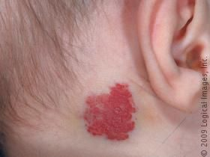
Haemangioma L18 slide 27
Gives itself away by: Red or bluish compressible mass that ENLARGES WITH CRYING or straining · 90% self-resolve
Presentation & who gets itA malformation of vascular tissue. Present in the first few months of life, grows rapidly through the first year, then begins to involute at 18 to 24 months. A red or bluish soft mass, compressible, that increases in size with straining or crying, with or without a bruit.Pain / where it sits / key findingNo · Superficial, any site · Enlarges with crying or straining; red or bluish, compressibleTesting & causeComputed tomography and magnetic resonance imaging.First-line treatment90% resolve without any therapy — observation alone. Intervene only for airway compromise, skin ulceration, dysphagia, thrombocytopenia or cardiac failure. First line: propranolol. Second line: systemic corticosteroids, interferon alpha, or surgical laser excision.Education & prognosisParents need the growth-then-involution curve explained, or the rapid first year reads as failure of treatment.
Slides 27

Teratoma Urgent
Gives itself away by: Firm neck mass noted at birth or in the first year · calcifications on imaging
Presentation & who gets itHead and neck teratomas account for 3.5% of all teratomas. They originate from pluripotent cells and present as firm neck masses, most commonly noted at birth or within the first year. A large one can cause respiratory compromise or dysphagia.Pain / where it sits / key findingNo · Any; noted at birth · Firm, with calcifications on imagingTesting & causeComputed tomography and magnetic resonance imaging — calcifications are the clue.First-line treatmentSurgical excision.Education & prognosisSize is the whole problem here: it is a benign lesion that can obstruct an airway.
Slides 28

Thymic cyst Routine
Gives itself away by: Slow-growing and asymptomatic · painful only if infected · Hassall corpuscles on biopsy
Presentation & who gets itPresents as a slow-growing, asymptomatic mass that may become painful if it is infected.Pain / where it sits / key findingOnly if infected · Lower anterior neck · Hassall corpuscles on biopsyTesting & causeMagnetic resonance imaging and computed tomography help with the differential. Definitive diagnosis is by biopsy — the presence of Hassall corpuscles.First-line treatmentSurgical excision.Education & prognosisThe histology is the diagnosis; imaging only narrows the list.
Slides 29

Sternocleidomastoid tumour of infancy Routine
Gives itself away by: Firm painless mass WITHIN the sternocleidomastoid · related to congenital torticollis
Presentation & who gets itRelated to congenital torticollis. A firm, painless, discrete mass within the sternocleidomastoid muscle that enlarges for 2 to 3 months and then regresses over 4 to 8 months.Pain / where it sits / key findingNo — painless · Within the sternocleidomastoid · Firm discrete mass with congenital torticollisTesting & causeClinical.First-line treatment80% resolve spontaneously and need only physical therapy to prevent restrictive torticollis. Surgical excision is reserved for persistent cases.Education & prognosisThe natural history is the treatment plan: it gets bigger before it gets better.
Slides 29

4.4 · Inflammatory neck masses

Reactive viral lymphadenopathy Routine
Gives itself away by: Commonest cause of cervical lymphadenopathy in CHILDREN · with an upper respiratory infection · regresses in 1–2 weeks
Presentation & who gets itThe commonest cause of cervical lymphadenopathy in children, associated with an underlying upper respiratory infection. Commonest pathogens are adenovirus, rhinovirus and enterovirus. Nodes regress in 1 to 2 weeks.Pain / where it sits / key findingMild · Cervical nodes, children · Regresses in 1–2 weeks with an upper respiratory infectionTesting & causeObservation is usually enough. A node larger than 1 cm is abnormal and needs investigation if it persists beyond 4 to 6 weeks or enlarges — biopsy then looks for fungal, granulomatous or neoplastic causes.First-line treatmentObservation.Education & prognosisThe two numbers that matter are 1 cm and 4 to 6 weeks; past either, it stops being reactive.
Slides 31

HIV-associated cervical adenopathy Urgent
Gives itself away by: Cervical adenopathy in 12–45% of patients with HIV · the neck is the commonest site
Presentation & who gets itCervical adenopathy is present in 12% to 45% of patients with HIV. Idiopathic follicular hyperplasia is the commonest cause. Persistent generalised lymphadenopathy — lymphadenopathy with no identifiable infectious or neoplastic cause — is also common, and the neck is its commonest site.Pain / where it sits / key findingNo · Neck is the commonest site · Follicular hyperplasia after tuberculosis and lymphoma are excludedTesting & causeRule out Mycobacterium tuberculosis, Pneumocystis carinii, lymphoma and Kaposi sarcoma before settling on hyperplasia.First-line treatmentTreat the HIV.Education & prognosisThe adenopathy is a marker of control, not a separate problem to excise.
Slides 32

Suppurative bacterial lymphadenopathy Urgent
Gives itself away by: Submandibular or jugulodigastric · with sore throat, skin lesions and upper respiratory symptoms
Presentation & who gets itMost commonly Staphylococcus aureus and group A beta-haemolytic Streptococcus. Masses develop in the submandibular or jugulodigastric regions, with sore throat, skin lesions and upper respiratory symptoms.Pain / where it sits / key findingYes · Submandibular or jugulodigastric · Sore throat and skin lesions with the nodeTesting & causeClinical; culture if aspirated.First-line treatmentEmpirical antibiotics against anaerobes and gram-positive organisms. Fine needle aspiration or incision and drainage if antibiotics fail.Education & prognosisFailure of antibiotics is the trigger to drain, not the starting point.
Slides 33

Cat scratch disease Routine
Gives itself away by: Contact with cats · under 20 years · preauricular and submandibular nodes
Presentation & who gets itBartonella henselae, with a history of contact with cats. Common under 20 years of age. Lymphadenopathy — commonly preauricular and submandibular — with fever and malaise.Pain / where it sits / key findingVaries · Preauricular and submandibular · Cat contact, patient under 20Testing & causeSerologic testing with indirect fluorescent antibodies.First-line treatmentSelf-limiting, or azithromycin.Education & prognosisSelf-limiting is the headline; azithromycin shortens it rather than being required.
Slides 34

Toxoplasmosis Routine
Gives itself away by: Undercooked meat or cat faeces · fever, malaise, sore throat, myalgias
Presentation & who gets itToxoplasma gondii, contracted through poorly cooked meat or ingestion of oocytes in cat faeces. Fever, malaise, sore throat and myalgias with the adenopathy.Pain / where it sits / key findingVaries · Cervical nodes · Undercooked meat or cat faeces in the historyTesting & causeSerologic testing.First-line treatmentSulfonamides or pyrimethamine.Education & prognosisOne of four exposure histories on the same slide — cat faeces here, cat scratch for Bartonella.
Slides 33

Tularemia Urgent
Gives itself away by: Rabbits, ticks, contaminated water · tonsillitis with painful adenopathy
Presentation & who gets itFrancisella tularensis, transmitted by rabbits, ticks and contaminated water. Tonsillitis, painful adenopathy, fever, chills, headache and fatigue.Pain / where it sits / key findingYes — painful adenopathy · Cervical nodes · Rabbits, ticks or contaminated water, with tonsillitisTesting & causeSerologic testing and cultures.First-line treatmentStreptomycin.Education & prognosisThe exposure history is the question: rabbits and ticks.
Slides 33

Brucellosis Routine
Gives itself away by: Unpasteurised milk · total body lymphadenopathy
Presentation & who gets itBrucella, transmitted by ingestion of unpasteurised milk, most commonly in children. Total body lymphadenopathy with fever, fatigue and malaise.Pain / where it sits / key findingNo · Total body, not just neck · Unpasteurised milkTesting & causeSerology and cultures.First-line treatmentTrimethoprim-sulfamethoxazole or tetracycline.Education & prognosisGeneralised rather than regional adenopathy is what sets it apart from the others on this slide.
Slides 33

Actinomycosis Routine
Gives itself away by: PAINLESS, fluctuant mass · submandibular or upper digastric
Presentation & who gets itPresents as a painless, fluctuant neck mass in the submandibular or upper digastric region.Pain / where it sits / key findingNo — painless · Submandibular or upper digastric · Painless and fluctuantTesting & causeClinical and biopsy.First-line treatmentPenicillin.Education & prognosisPainless and fluctuant together is the combination that points here.
Slides 34

Atypical mycobacteria Urgent
Gives itself away by: Children · UNILATERAL · brawny reddish-brown skin over the mass
Presentation & who gets itA paediatric infection. A unilateral neck mass in the anterior triangle or the parotid gland, with brawny (reddish-brown) skin, induration and pain.Pain / where it sits / key findingYes · Unilateral, anterior triangle or parotid · Brawny reddish-brown skin over it, in a childTesting & causeStain or culture for acid-fast bacilli, plus skin testing.First-line treatmentSurgical excision, or incision and drainage with antibiotics.Education & prognosisUnilateral and paediatric here; tuberculous adenitis is more diffuse and bilateral.
Slides 34

Tuberculous adenitis (scrofula) Urgent
Gives itself away by: Adults more than children · DIFFUSE and BILATERAL
Presentation & who gets itMycobacterium tuberculosis. Cervical tuberculosis is called scrofula. Adults are affected more than children, and the lymphadenopathy is more diffuse and bilateral than in atypical mycobacterial disease.Pain / where it sits / key findingVaries · Bilateral and diffuse · Adults more than children; acid-fast bacilliTesting & causeTuberculin skin test, stain and culture for acid-fast bacilli.First-line treatmentIsoniazid, rifampin, rifabutin, rifapentine, pyrazinamide, ethambutol — traditionally RIPE: rifampin, isoniazid, pyrazinamide, ethambutol.Education & prognosisBilateral and diffuse versus unilateral and brawny is the whole distinction from atypical mycobacteria.
Slides 34

Fungal neck infection Urgent
Gives itself away by: Immunocompromised · Candida, Histoplasma, Aspergillus
Presentation & who gets itImmunocompromised patients are particularly susceptible. The commonest organisms are Candida, Histoplasma and Aspergillus.Pain / where it sits / key findingVaries · Cervical nodes · Immunocompromised host; fungal culture and serologyTesting & causeFungal cultures and serology are required — the deck is emphatic about this.First-line treatmentAmphotericin B, treated aggressively.Education & prognosisNon-infectious inflammatory causes sit on the same slide: Sjögren syndrome, sarcoidosis, IgG4-related sialadenitis and Kawasaki disease.
Slides 35

4.5 · Neoplastic neck masses

Neck neoplasm — general Emergent
Gives itself away by: Presume any new neck mass is MALIGNANT until proven otherwise · firm, slowly progressive, asymptomatic
Presentation & who gets itBenign tumours arise from the soft tissue of the neck — fat, salivary tissue, lymph nodes, blood vessels, nerves. Malignant ones are usually metastatic squamous cell carcinoma from skin or the upper aerodigestive tract. Hoarseness, dysphagia and odynophagia are the symptoms; the lesion itself is asymptomatic, slowly progressive and firm.Pain / where it sits / key findingNo — asymptomatic · Cervical nodes, often jugulodigastric · Firm, immobile, over 1.5 cm, present over 2 weeksTesting & causeComplete head and neck examination, then fine needle aspiration biopsy rather than excisional biopsy — excision spills tumour and complicates definitive treatment. Fiberoptic laryngoscopy for an occult primary; ultrasound, contrast computed tomography, magnetic resonance imaging, positron emission tomography.First-line treatmentDirected by the primary once it is found. Once the diagnosis is confirmed, all mucosal surfaces of the head and neck, the thyroid, the salivary glands and the skin are examined — the office examination usually finds the primary.Education & prognosisThe malignancy features from slide 13: no infectious origin, duration over 2 weeks, size over 1.5 cm, firm and non-tender with little mobility, age over 40, tobacco and alcohol, and ulceration.
Slides 37, 39

Primary neck tumours — the list Emergent
Gives itself away by: Slide 38 is a picture of a table · malignant against benign, primary in the neck
Presentation & who gets itMalignant: sarcomas (rhabdomyosarcoma, fibrosarcoma, malignant fibrous histiocytoma, liposarcoma, leiomyosarcoma); malignant peripheral nerve sheath tumours; lymphoma; and metastasis — mucosal cancer from head and neck, salivary malignancies, skin malignancies. Benign: vascular neoplasms, chiefly paragangliomas (carotid body, vagal, jugulotympanic); arteriovenous malformations; peripheral nerve neoplasms (schwannomas, neurofibromas, neuromas); and lipomas.Pain / where it sits / key findingVaries · Neck soft tissue · Pulsatile or bruit means paragangliomaTesting & causeAs for any neck neoplasm — fine needle aspiration first.First-line treatmentBy tumour type.Education & prognosisA pulsatile mass or a bruit means vascular, and paraganglioma heads that list.
Slides 38

4.6 · The thyroid

Thyroid nodule and mass Urgent
Gives itself away by: MIDLINE mass that ELEVATES WITH SWALLOWING · the main cause of an anterior neck lump
Presentation & who gets itThe main cause of anterior neck masses and lumps. An immobile midline neck mass that elevates with swallowing is likely thyroid. Risk factors: age under 30 or over 60, childhood head and neck irradiation, full body irradiation for bone marrow transplant, family history of thyroid cancer, and multiple endocrine neoplasia type 2. Recent growth, dysphagia or obstruction are the concerning symptoms.Pain / where it sits / key findingNo · Midline anterior neck · Elevates with swallowing; hot nodule needs no biopsyTesting & causeUltrasound with fine needle aspiration, thyroid-stimulating hormone, T3 and T4. Incidental nodules over 1 cm need evaluation. If hyperthyroid with a low thyroid-stimulating hormone, do a radionuclide scan with technetium BEFORE the aspiration: a “hot” (hyperfunctioning) nodule needs no biopsy, while a “cold” or “warm” nodule does.First-line treatmentDetermined by the biopsy. Fine needle aspiration is the diagnostic procedure of choice once primary thyroid disease has been excluded on labs.Education & prognosisIf thyroid cancer is suspected, avoid iodine-contrast computed tomography — it compromises radioiodine treatment afterwards.
Slides 40–41

Papillary thyroid carcinoma Urgent
Gives itself away by: Commonest (75%) · best prognosis · young women
Presentation & who gets itThe commonest thyroid cancer at 75%, with the best prognosis, commonest in young females. Involves thyroid epithelial cells.Pain / where it sits / key findingNo · Thyroid · Commonest at 75%, best prognosis, young womenTesting & causeFine needle aspiration.First-line treatmentLobectomy or thyroidectomy, with or without neck dissection, ablation and surveillance. Almost all thyroid cancers need thyroidectomy, except a well-differentiated cancer localised to one lobe with no metastasis.Education & prognosisCommonest and kindest — the pairing is the exam point.
Slides 42, 44

Follicular thyroid carcinoma Urgent
Gives itself away by: Second commonest (16%) · spreads by BLOOD to bone and lung
Presentation & who gets it16% of thyroid cancers, involving thyroid epithelial cells. Spreads to local lymph nodes or by blood to bone and lungs. The Hürthle cell variant is more aggressive, with a higher risk of metastases and recurrence.Pain / where it sits / key findingNo · Thyroid · Spreads by blood to bone and lungTesting & causeFine needle aspiration.First-line treatmentAs for papillary: lobectomy or thyroidectomy with or without neck dissection and ablation.Education & prognosisHaematogenous spread is what separates it from papillary.
Slides 42, 44

Medullary thyroid carcinoma Urgent
Gives itself away by: About 5% · parafollicular C cells · calcitonin · screen for MEN
Presentation & who gets itAbout 5%. A disorder of the parafollicular or C cells, which produce calcitonin. More insidious, most likely to metastasise, and can go undiagnosed until a metastasis is found.Pain / where it sits / key findingNo · Thyroid · C cells and calcitonin; screen for multiple endocrine neoplasiaTesting & causeFine needle aspiration; calcitonin.First-line treatmentThyroidectomy with monitoring for recurrence on screening labs, with or without external beam radiation for nodal disease. Screen family members for multiple endocrine neoplasia.Education & prognosisThe only one of the four with a familial syndrome to chase in the relatives.
Slides 42, 44

Anaplastic thyroid carcinoma Emergent
Gives itself away by: 1% · elderly · death in 6–36 months · resistant to all treatment
Presentation & who gets it1% of thyroid cancers, commonly in elderly patients. Small cell, giant cell and spindle cell types. The most aggressive form — death in 6 to 36 months — and resistant to all treatment modalities.Pain / where it sits / key findingVaries · Thyroid · Elderly; death in 6–36 monthsTesting & causeFine needle aspiration; staging imaging.First-line treatmentIsthmectomy rather than thyroidectomy.Education & prognosisThe one thyroid cancer where the prognosis is measured in months.
Slides 42, 44

Primary thyroid lymphoma Urgent
Gives itself away by: Associated with Hashimoto thyroiditis · non-Hodgkin B cell
Presentation & who gets itMost commonly non-Hodgkin B cell tumours, associated with Hashimoto thyroiditis.Pain / where it sits / key findingNo · Thyroid · Hashimoto thyroiditis in the backgroundTesting & causeFine needle aspiration alone cannot separate lymphoma from Hashimoto — a biopsy is needed to confirm, along with lymphoma staging.First-line treatmentChemotherapy and radiation — not primarily surgical, unlike the carcinomas above.Education & prognosisThe one thyroid malignancy where the answer is not an operation.
Slides 45

5 · Disorders of the Oral Cavity, Salivary Glands and Neck
INSTRUCTIONAL OBJECTIVES
DISORDERS OF THE EARS, NOSE, THROAT AND NECK — Disorders of the Oral Cavity, Salivary Glands, and Neck
- Compare and contrast the etiologies, epidemiology, risk factors, clinical manifestations, differential diagnosis, diagnostic testing (including ordering and interpretation), management (acute and chronic, including applicable rehabilitative and palliative care), appropriate referrals, patient education, and prognosis of the following disorders of the oral cavity, salivary glands, and neck:
- Stomatitis
- Ulcers
- Aphthous ulcerations
- Recurrent aphthous stomatitis (including herpetiform morphology)
- Herpes simplex virus ulcers
- Sialadenitis
- Sialolithiasis
- Parotitis
- Laryngitis
- Vocal cords
- Nodules
- Polyps
- Papillomatosis
- Paralysis
- Epiglottitis
- Pharyngitis
- Epstein-Barr virus (EBV) and infectious mononucleosis
- Rheumatic fever (as potential complication of strep pharyngitis)
- Oral Candidiasis
- Tonsillitis
- Cervical adenitis
- Deep neck infections
- Peritonsillar abscess
- Retropharyngeal abscess
- Ludwig angina
- Diphtheria
- Gingivitis
- Dental caries
- Dental abscess
- Temporomandibular joint disorders
- Diseases of gingiva
- Diseases of teeth
- Lichen Planus
- Oral leukoplakia
- Neoplasms: 1. Benign · 2. Malignant
- Oropharyngeal trauma
- Identify medical care strategies for disorders of the oral cavity, salivary glands, and neck in the lecture topic list for the following populations: 1. adolescent · 2. adult · 3. elderly

NOTE
The biggest lecture in the block by a distance — 151 slides, and the objective list above runs to 35 conditions. It has no recording, so everything below is slide content.

5.1 · Examining the mouth, and the salivary anatomy
The oral cavity is the outer aspects of the lips and buccal mucosa, the teeth and gingiva, the anterior two thirds of the tongue, the floor of the mouth, the hard palate and the retromolar trigone. Over 80% of surveyed clinicians believe oral examination is important, and far fewer actually do one — which is the lecture's argument for the section. Take a careful medical and medication history first: xerostomia, immunosuppression and chemotherapy change what you are looking at.
Gland | Duct | Where it opens
Parotid | Stensen duct | Sides of the face; the duct crosses the masseter and opens opposite the upper second molar. The gland most often affected by suppurative sialadenitis and by neoplasm.
Submandibular | Wharton duct | Beneath the floor of the mouth. The long, upward-running duct is why 80–90% of stones form here.
Sublingual | Sublingual ducts | Floor of the mouth. The source of a ranula.
Minor | — | Exocrine tissue in buccal, labial and palatal mucosa. Only 35% of minor gland tumours are benign — the smaller the gland, the likelier a tumour is malignant.

NOTE
The scrape test settles three diagnoses at the bedside. Wipe the lesion with a tongue depressor. It comes off → oral candidiasis. It does not come off and it is white → leukoplakia (premalignant, 5–20% become squamous cell carcinoma). It does not come off and it is lacy → lichen planus (Wickham striae). And a fourth: a greyish-white change that disappears when you stretch the mucosa is leukoedema, a normal variant.

★ PROFESSOR EMPHASIS
★ MUST KNOW
Prof. Shah, [1:34:40]: “Centor criteria is something that everyone most definitely needs to know. Like, you absolutely need to know the Centor criteria, no matter what… So I don’t know how you’re going to know that, but you need to know that. That means you need to come up with an acronym, you need to come up with a song, you need to dance it out — whatever you need to do to make sure you know it. You’re going to be using this all the time.” She then worked it through component by component and score by score [1:22:47–1:24:23], and framed it around the question students get stuck on — the rapid test is negative, now what? Answer: throat culture, and whether you treat “depends on how sick they are.”
The antipyretic trap on the fever point [1:33:00], which is not on the slide. Fever scores a point, but a normal temperature in clinic does not automatically score zero. If they took ibuprofen six hours ago and are still 102 °F in front of you, that counts. If they took it two hours ago and read 99.9, the number in front of you is not the answer — ask what their maximum temperature was, how many days they have had fever, the highest reading in the past 24 hours, and whether the fever returns as the next dose comes due.
Centor criteria, and what to do with the score (slides 74–77). One point each for absence of cough, tonsillar exudate, fever, and tender anterior cervical lymphadenopathy; plus +1 for age 3–14, 0 for age 15–44, and −1 for age 45 or over.
Score 0 to 1 — risk of group A streptococcus roughly 1–10%; no further testing and no antibiotics. Score 2 to 3 — risk roughly 11–35%; perform a rapid antigen test or culture and treat only if positive. Score 4 or more — risk roughly 51–53%; consider empiric treatment. A negative rapid test is always confirmed with a throat culture, and the definitive test is antistreptolysin O, which matters because carriers culture positive while asymptomatic.

Streptococcal against viral pharyngitis (the comparison on slide 71). The streptococcal picture is tonsillar and pharyngeal erythema with purulent exudate, fever above 100.4 °F, tender cervical nodes and NO cough. The viral picture brings the things streptococcus does not: cough, rhinitis, hoarseness, conjunctivitis, and sometimes herpangina — ulcerative vesicles over the tonsils. Cough is worth a Centor point in its absence precisely because its presence argues so strongly against strep.
The thumbprint sign (slide 64) is the swollen epiglottis seen on a lateral neck X-ray, set against the thin, curved normal epiglottis. It is worth recognising and worth not ordering: the lecture is explicit that it is not necessary for diagnosis, and that once epiglottitis is suspected, examinations that agitate the patient can complete the obstruction.
★ PROFESSOR EMPHASIS
★ SHE SAID “BAD, BAD, BAD”
Four times in this lecture — two diagnoses, and two single findings that turn an ordinary presentation into an urgent one, which is the more useful half of the list. She also uses it once in the negative, which is what shows the phrase is a deliberate grade rather than a verbal tic.
Chronic laryngitis [59:40]. “Chronic laryngitis is where you have vocal disturbances that go on for more than two weeks… Here, your brain should automatically be thinking of cancer or polyps, right? Something bad, right? Bad, bad, bad. And in these instances, you have to refer to ENT as soon as possible, like ASAP, like yesterday.” The two-week mark is the trigger and the referral is the answer — not a longer course of anything.
Epiglottitis [1:00:05]. She notes first that supraglottitis is “a much more correct terminology”, because the inflammation involves several supraglottic structures rather than one. Then: “This is an absolute emergency, okay? Emergency. This is bad. This is bad, bad, bad. You cannot miss this diagnosis. This will hurt the patient. This will kill the patient if it’s missed.” Read it with the thumbprint paragraph above: the film is not what makes the diagnosis, and examining the throat can finish the airway.
A neck mass that does not move. Running through what a node examination must document — site, size, consistency, tenderness — she reaches mobility: “If it’s immobile, not moving, that is bad. That is bad, bad, bad.” And she gives the word to write: document it as immobile or FIXED, “because that’s telling whoever’s reading it that it’s not moving and it’s stuck to whatever location it is.” The finding is the alarm; the wording is how you pass the alarm on.
A rim-enhancing hypodense collection on computed tomography. Her described classic for a deep neck abscess — an enhancing rim around a sac of fluid. “So this is bad. Now we’ve like bad, bad, bad, right? Protect the airway. This is a surgical emergency.” Antibiotics must cover streptococci, staphylococci and anaerobes. She was counting as she went — this was the second emergency of the lecture.
And the one she says is NOT. Leukoplakia [2:37:42]: it does not scrape off, and it may bleed if you try — “This is a pre-malignant lesion. This is bad… not bad, bad, bad, but bad enough where we have to work it up relatively quickly.” Useful in both directions: it fixes leukoplakia one rung below the four above, and it confirms the phrase is how she grades urgency out loud.

5.2 · Normal variants of the oral mucosa

Leukoedema Routine
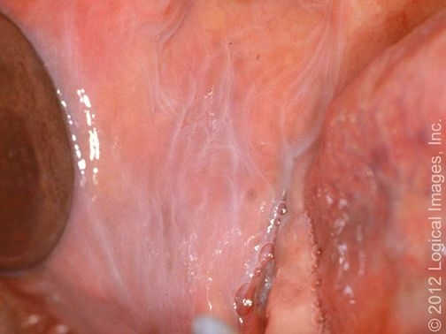
Leukoedema L19 slide 9
Gives itself away by: Normal variant · greyish-white buccal mucosa that DISAPPEARS WHEN STRETCHED
Presentation & who gets itA common, benign mucosal change and a normal variant, caused by accumulation of fluid within the epithelial cells. Diffuse greyish-white appearance of the buccal mucosa.Pain / where it sits / key findingNo · Buccal mucosa · Disappears when the mucosa is stretchedTesting & causeClinical. The distinguishing manoeuvre is stretching the mucosa — the change disappears, which is what separates it from leukoplakia.First-line treatmentNone — reassurance.Education & prognosisNaming it as a variant is the whole job; it needs no biopsy and no follow-up.
Slides 9

Fordyce granules Routine
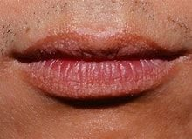
Fordyce granules L19 slide 10
Gives itself away by: Normal variant · ectopic sebaceous glands · yellow-white papules on lip or buccal mucosa
Presentation & who gets itNormal variants — ectopic sebaceous glands in a site where sebaceous glands are not expected. Small yellow-white papules on the vermilion of the lip and the buccal mucosa.Pain / where it sits / key findingNo · Vermilion of lip, buccal mucosa · Yellow-white papules — ectopic sebaceous glandsTesting & causeClinical.First-line treatmentNone — reassurance.Education & prognosisPatients find them alarming because they appear suddenly to the person looking; they have always been there.
Slides 10

Physiologic pigmentation Routine
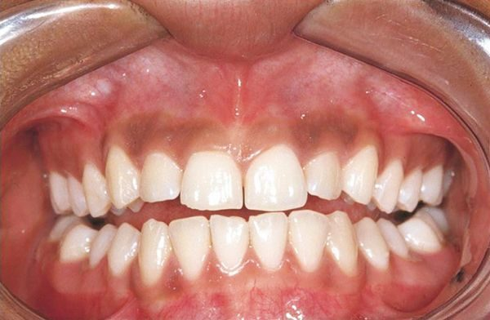
Physiologic pigmentation L19 slide 11
Gives itself away by: Normal variant · symmetrical melanin pigmentation, commoner in darker skin
Presentation & who gets itPhysiologic oral pigmentation is commonly seen and is a normal variant, from melanin.Pain / where it sits / key findingNo · Gingiva and mucosa · Symmetrical melanin pigmentation, a normal variantTesting & causeClinical.First-line treatmentNone — reassurance.Education & prognosisThe reason it matters is the differential it sits in, not the lesion itself.
Slides 11

5.3 · Stomatitis and oral ulcers

Aphthous stomatitis (canker sores) Routine
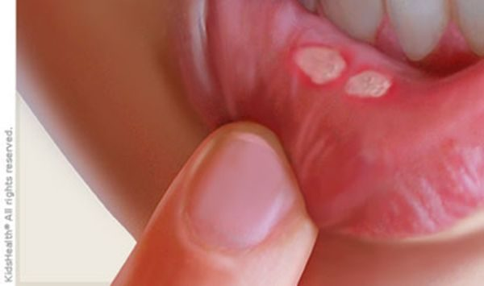
Aphthous stomatitis (canker sores) L19 slide 15
Gives itself away by: Painful round ulcer, YELLOW-GREY fibrinoid centre with a RED HALO · on non-keratinised, freely moving mucosa
Presentation & who gets itThe commonest cause of acute recurrent oral ulcers in adolescents and young adults. Found on freely moving, non-keratinised mucosa — buccal and labial mucosa, non-attached gingiva, palate. Trauma (cheek biting, a dental procedure) and stress are exacerbating factors; the cause is unknown, though human herpesvirus 6 has been suggested. Minor (<1 cm) are commonest, burn and tingle first, and last 7–10 days. Major (>1 cm) are more painful, multiple, scar, and last over a month. Herpetiform are numerous 1–3 mm ulcers, scar, and last over a month.Pain / where it sits / key findingYes — painful · Non-keratinised, freely moving mucosa · Yellow-grey fibrinoid centre with a red haloTesting & causeClinical.First-line treatmentObservation — it is self-limiting. Anti-inflammatories, antibiotics, antivirals, oral and topical corticosteroids (triamcinolone, fluocinonide), cauterisation with silver nitrate, Lactobacillus capsules, dilute water rinses.Education & prognosisRecurrent aphthous stomatitis is called Sutton disease. Non-keratinised mucosa is the location rule that separates it from herpes.
Slides 15–17

Herpes simplex ulcers Routine
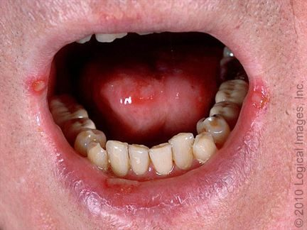
Herpes simplex ulcers L19 slide 25
Gives itself away by: Prodrome of burning and tingling ~24 h BEFORE the lesion · recurrence from the trigeminal ganglion
Presentation & who gets itHerpes simplex virus 1 and 2. Herpetic gingivostomatitis is the commonest manifestation of primary infection in children and young adults, with fever, malaise and cervical lymphadenopathy. Secondary disease is recurrence of dormant virus from the trigeminal ganglion, triggered by stress, trauma, immunosuppression or ultraviolet light. Small painful lesions that ulcerate, leaving an erythematous base with a grey cover; heals without a scar; resolves in 1–2 weeks.Pain / where it sits / key findingYes · Perioral and oral, keratinised surfaces · Burning prodrome ~24 h before the lesionTesting & causeClinical, but confirm with polymerase chain reaction for HSV DNA — most sensitive and specific. Serology with IgG and IgM distinguishes HSV 1 from HSV 2. Tzanck smear shows multinucleated giant cells but is also positive in varicella zoster, so it is not the best test.First-line treatmentOral acyclovir for treatment and prophylaxis.Education & prognosisThe 24-hour prodrome is the window in which treatment works best, so patients are taught to recognise it.
Slides 25–27

Behcet syndrome Urgent
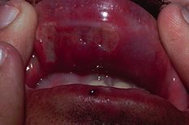
Behcet syndrome L19 slide 19
Gives itself away by: Oral ulcers in up to 100% · GENITAL ulcers in 75% · multisystem
Presentation & who gets itAn inflammatory, multisystem disorder with vascular, articular, gastrointestinal, neurologic, urogenital, pulmonary and cardiac involvement. Oral ulcers are the commonest feature, affecting up to 100% of patients. Genital ulcers occur in about 75% and look like oral aphthae.Pain / where it sits / key findingYes · Oral and genital · Oral ulcers in up to 100%, genital in 75%Testing & causeClinical — recurrent aphthous ulceration in the context of the characteristic systemic manifestations.First-line treatmentNo cure. Corticosteroids, intravenous immunoglobulin, immunosuppressives — colchicine, azathioprine, cyclosporine-A, interferon alpha, cyclophosphamide.Education & prognosisThe oral ulcers look ordinary; it is the genital ulcers and the systemic features that make the diagnosis.
Slides 19

Oral lichen planus Urgent
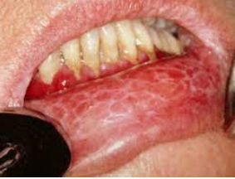
Oral lichen planus L19 slide 21
Gives itself away by: WICKHAM STRIAE — lacy white lines on buccal mucosa · 1–4% become squamous cell carcinoma
Presentation & who gets itA common chronic inflammatory autoimmune disorder in which the basal layer is destroyed by activated lymphocytes. May be familial or drug-induced (penicillamine, methyldopa, phenothiazine, antimalarials). Classically purple, polygonal, pruritic papules on flexor surfaces and trunk; 60–70% affect lips, oral mucosa and eyelids, and the oral lesions are more chronic. Kobner isomorphic phenomenon — lesions provoked by physical trauma. Types: reticular (lacy white Wickham striae), plaque (looks like leukoplakia), atrophic, erosive and bullous, ulcerative, annular.Pain / where it sits / key findingVaries — erosive types hurt · Buccal mucosa, tongue, lips · Wickham striae — lacy white linesTesting & causeClinical, with biopsy where malignancy is a concern.First-line treatmentAimed at pain relief. Identify reversible contributors — medications, dental restorations, oral hygiene, tobacco and alcohol. Topical or oral corticosteroids; lidocaine, tacrolimus, cyclosporine.Education & prognosis1–4% progress to squamous cell carcinoma, and the risk is higher with ulcerative lesions — which is why close follow-up is the point of the diagnosis.
Slides 20–22

Systemic lupus erythematosus — oral Urgent
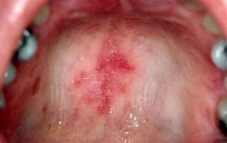
Systemic lupus erythematosus — oral L19 slide 23
Gives itself away by: 40% of patients with lupus · oral lesions may be the FIRST SIGN · honeycomb patches
Presentation & who gets it40% of patients with systemic lupus erythematosus have mucous membrane involvement, and oral lesions may be the first sign of lupus. Painful or painless, with no correlation to systemic activity. Lesions: cheilitis, erythematous patches, honeycomb patches, discoid and discrete ulcers. White plaques, erythematous areas and punched-out erosions with surrounding erythema on the soft and buccal mucosa.Pain / where it sits / key findingVaries · Lips, soft and buccal mucosa · Honeycomb patches; may be the first sign of lupusTesting & causeClinical, with serology for the systemic disease.First-line treatmentPhotoprotection plus medication: topical or intralesional corticosteroids, topical calcineurin inhibitors, systemic glucocorticoids, and systemic antimalarials — hydroxychloroquine or chloroquine.Education & prognosisThe oral ulcers do not track disease activity, so they cannot be used to judge control.
Slides 23–24

5.4 · Salivary glands

Acute suppurative sialadenitis Urgent
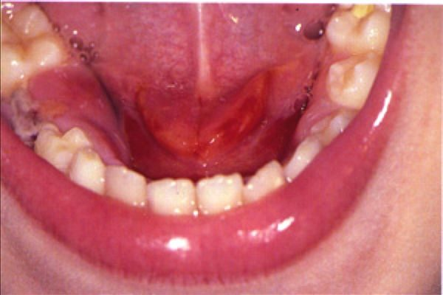
Acute suppurative sialadenitis L19 slide 35
Gives itself away by: PAROTID swelling, firm and diffusely tender · PUS EXPRESSED FROM THE DUCT · dehydrated post-operative or elderly patient
Presentation & who gets itBacterial infection of a salivary gland, beginning with stasis of salivary flow. Occurs in post-operative patients, elderly patients with chronic conditions, and children under 2 months. Risk factors: dehydration, trauma, immunosuppression, chemotherapy or radiation, age over 50, HIV, xerostomia, sialolithiasis, anorexia and bulimia. Staphylococcus aureus is the commonest pathogen. The parotid is most commonly affected: unilateral, firm, diffusely tender, with overlying erythema, trismus, purulent ductal discharge, induration, fever and chills.Pain / where it sits / key findingYes — firm, diffusely tender · Parotid, unilateral · Pus expressed from the ductTesting & causeClinical is usually sufficient. If uncertain: culture, and ultrasound, computed tomography or magnetic resonance imaging to look for stones, abscess or gland inflammation.First-line treatmentRehydration plus intravenous antibiotics with penicillinase-resistant gram-positive cover (nafcillin or cefazolin), then oral (dicloxacillin, clindamycin). Warm compresses, massage, sialogogues (lemon drops or vitamin C lozenges), oral hygiene. No improvement in 48 hours means presume an abscess.Education & prognosisSubmandibular disease that fails treatment can mimic Ludwig angina, which threatens the airway.
Slides 34–39

Sialolithiasis Routine
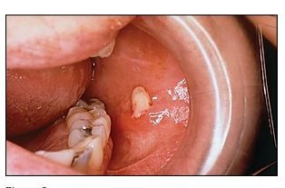
Sialolithiasis L19 slide 36
Gives itself away by: Recurrent swelling and pain WORSE WITH EATING (salivary colic) · 80–90% SUBMANDIBULAR
Presentation & who gets itSalivary calculi. Change in saliva viscosity, ductal injury or stagnation causes calcium phosphate and calcium carbonate to precipitate. 80–90% occur in the submandibular gland — the duct runs a longer course, and the saliva has higher mucin, alkaline content, calcium and phosphate. 10–20% parotid. Commoner in men. Risk: long illness with dehydration, gout, diabetes, hypertension.Pain / where it sits / key findingYes — with eating · Submandibular duct in 80–90% · Salivary colic — swelling and pain on eatingTesting & causeUsually clinical. Submandibular stones are calcium phosphate and hydroxyapatite, so they are RADIOPAQUE and visible on plain films. Ultrasound shows an echogenic structure with acoustic shadow; computed tomography is the most sensitive; digital subtraction sialography is the most accurate. Stones may be palpable in the anterior two thirds of the duct.First-line treatmentBy location and size: intraoral extraction if palpable or visible anteriorly; gland excision for large stones in the hilum or body; sialoendoscopy, the minimally invasive option that can avoid removing the gland; lithotripsy. Conservative: hydration, hot compresses, massage, non-steroidal anti-inflammatories, lozenges.Education & prognosisPain that arrives with the first mouthful and settles afterwards is the history that makes this diagnosis without any test.
Slides 40–43

Parotitis Routine
Gives itself away by: Painful parotid swelling · mumps (paramyxovirus) is the classic viral cause
Presentation & who gets itPainful swelling of the parotid gland. Causes: viral — mumps (paramyxovirus), herpes, Epstein-Barr virus — and also bacterial infection, diabetes, tumours, stones and dental problems.Pain / where it sits / key findingYes · Parotid · Mumps is the classic viral causeTesting & causeClinical; serology where mumps is suspected.First-line treatmentDirected at the cause.Education & prognosisIt is a presentation, not a single disease — the work is deciding which of the causes it is.
Slides 44

5.5 · Vocal cords and larynx

Vocal cord nodules Routine
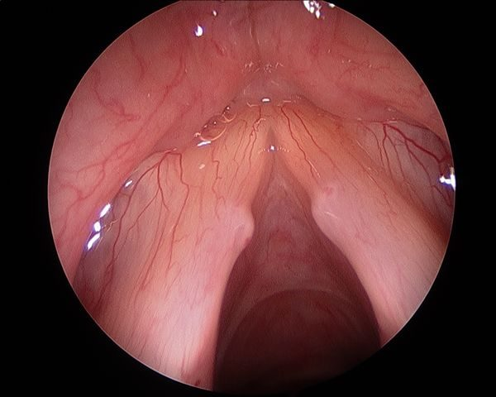
Vocal cord nodules L19 slide 47
Gives itself away by: BILATERAL and SYMMETRIC · junction of the anterior one third and posterior two thirds · vocal abuse
Presentation & who gets itSmooth, paired lesions at the junction of the anterior one third and posterior two thirds of the vocal folds, from vocal abuse. The commonest cause of persistent dysphonia in children — screamers' nodules, and a frequent cause of voice deterioration in professional singers — singers' nodules.Pain / where it sits / key findingNo · Anterior third / posterior two thirds junction · Bilateral and symmetricTesting & causeLaryngoscopy: small, well-defined lesions with a whitish hue, bilateral and symmetric.First-line treatmentSpeech therapy is first line in adults and children. Photodocumentation in the voice clinic tracks progress; microlaryngoscopy if needed.Education & prognosisBilateral and symmetric is the finding that separates nodules from a polyp, which is unilateral.
Slides 46–47

Vocal cord polyps Urgent
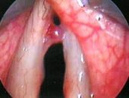
Vocal cord polyps L19 slide 48
Gives itself away by: UNILATERAL, pedunculated · men with vocal abuse and heavy smoking
Presentation & who gets itUnilateral masses forming within the superficial lamina propria of the vocal fold, commoner in men with a history of vocal abuse and heavy smoking. Fluid-filled and gelatinous, pedunculated, sometimes with visible vascular markings, at the point of maximal vibration.Pain / where it sits / key findingNo · Superficial lamina propria, one fold · Unilateral and pedunculatedTesting & causeMicrolaryngoscopic examination with excision — which both confirms the diagnosis and excludes other pathology.First-line treatmentExcision of the polyp, with continued vocal rest and smoking cessation.Education & prognosisA large polyp may conceal an occult early laryngeal squamous cell carcinoma, which is why it is excised rather than watched.
Slides 48

Vocal cord papillomatosis Urgent
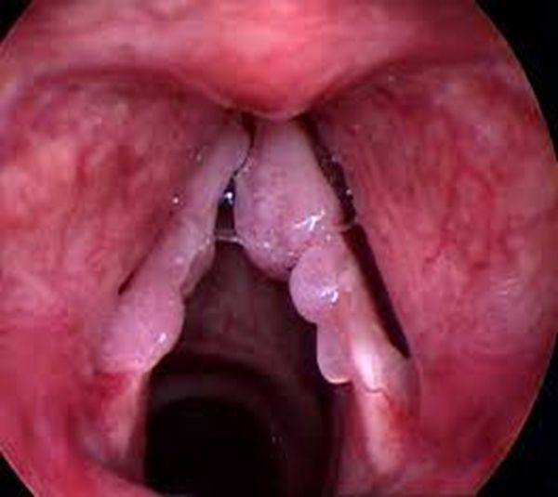
Vocal cord papillomatosis L19 slide 49
Gives itself away by: Warty exophytic growths in the larynx · HPV 6 and 11 · bimodal — ages 2–4 and the 30s
Presentation & who gets itRecurrent respiratory papillomatosis: benign, non-contagious, rare, with exophytic warty lesions usually in the larynx but also nose, pharynx and trachea. Human papillomavirus subtypes 6 and 11, rarely 16. Bimodal: juvenile between 2 and 4 years, adult peaking in the 30s. Multiple friable irregular warty growths affecting true and false cords, at points of air turbulence and at the change from ciliary to squamous epithelium. Glottic lesions cause dysphonia; supraglottic lesions cause stridor.Pain / where it sits / key findingNo · True and false cords · Warty exophytic growths; HPV 6 and 11Testing & causeLaryngoscopy.First-line treatmentNo curative measure for the virus — the aim is removing symptomatic lesions with minimal morbidity: carbon dioxide laser resection, cold steel dissection, laryngeal microdebrider. Avoid tracheostomy, which introduces another squamociliary junction the papillomas favour. Adjuvant intralaryngeal cidofovir is off-label.Education & prognosis3–7% risk of malignant transformation. Gardasil and Gardasil 9 offer eventual prevention.
Slides 49–52

Vocal cord paralysis Urgent
Gives itself away by: Unilateral: hoarse BREATHY voice · bilateral: STRIDOR with a weak cry
Presentation & who gets itOne or both folds fail to open or close properly. Causes: injury during surgery to thyroid, parathyroid, oesophagus, neck or chest; neck or chest injury; tumours; infections (Lyme disease, Epstein-Barr virus, herpes); neurological disease (stroke, multiple sclerosis, Parkinson disease). Unilateral gives hoarse breathy dysphonia, aspiration, dysphagia, vocal fatigue — and may be asymptomatic. Bilateral gives inspiratory or biphasic stridor, weak cry, aspiration.Pain / where it sits / key findingNo · One or both folds · Unilateral breathy voice; bilateral stridorTesting & causeMirror laryngoscopy or flexible nasolaryngoscopy plus a full neurological examination. Determine whether the lesion is the recurrent laryngeal nerve or the vagus, and whether it is unilateral or bilateral.First-line treatmentDecide whether it is self-limiting or permanent. Observation with voice therapy; surgical medialisation of the affected fold, or thyroplasty.Education & prognosisLaryngeal electromyography predicts recovery: a transected or tumour-infiltrated nerve will not recover, while a bruised or stretched one may return over 6 months to a year.
Slides 53–56

Acute laryngitis Routine
Gives itself away by: Commonest cause of hoarseness · persists about a week after the upper respiratory infection clears
Presentation & who gets itThe commonest cause of hoarseness, persisting about a week after upper respiratory symptoms have cleared. Viral (rhinovirus commonest, parainfluenza, respiratory syncytial virus, adenovirus, influenza, pertussis), bacterial or fungal; also acid reflux, smoking, toxic inhalation, cough, vocal abuse, direct injury and allergy. Dysphonia, low-grade fever, hoarseness, cough, rhinitis and postnasal drip.Pain / where it sits / key findingMild · Larynx · Hoarseness persisting a week after the cold clearsTesting & causeClinical.First-line treatmentConservative: hydration, antipyretics, voice rest, decongestants, humidification, smoking cessation. Antibiotics are not indicated unless a secondary bacterial infection is suspected.Education & prognosisVoice rest is the treatment patients most often skip and most need.
Slides 57

Chronic laryngitis Urgent
Gives itself away by: Voice disturbance lasting more than 2 weeks · NOT a true diagnosis — work it up
Presentation & who gets itVoice disturbance lasting more than two weeks. Not a true diagnosis — always work up the underlying condition.Pain / where it sits / key findingNo · Larynx · Over 2 weeks — scope it, do not treat itTesting & causeRefer to ear, nose and throat for laryngoscopy. Laryngeal cancer and vocal cord polyps must be considered.First-line treatmentTreat what the laryngoscopy finds.Education & prognosisTwo weeks of hoarseness is the threshold at which a smoker gets scoped, not reassured.
Slides 58

5.6 · The airway emergency

Epiglottitis (supraglottitis) Emergent
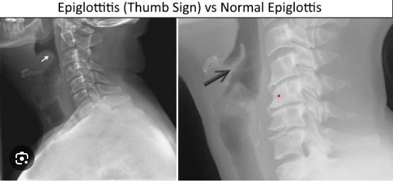
Epiglottitis (supraglottitis) L19 slide 64
Gives itself away by: ENT EMERGENCY · the 4 Ds in children — Drooling, Dysphagia, Dysphonia, Distress · TRIPOD position
Presentation & who gets itMore correctly supraglottitis: cellulitis involving multiple areas of the supraglottis. Acute disease presents in children aged 2 to 6, though any age can be affected. Commonest pathogen is Haemophilus influenzae type B — incidence has fallen over 90% since the vaccine. Others: Streptococcus pneumoniae, Staphylococcus aureus, beta-haemolytic streptococci. Children: the 4 Ds. Adults: severe sore throat, dysphagia, odynophagia, fever, dyspnoea, cough; muffled voice, stridor and drooling in under 10%. Sudden onset progressing over hours in children, more slowly in adults. Classic picture is an irritable patient sitting or leaning forward, neck hyperextended, chin thrust forward. Inspiratory stridor is a LATE finding — the airway is nearly obstructed.Pain / where it sits / key findingSevere — odynophagia · Supraglottis · Tripod position, drooling, muffled voice; thumbprint signTesting & causeOnce suspected, do NOT perform an intraoral examination or venipuncture — the anxiety they cause may complete the obstruction. Lateral neck X-ray shows the “thumb print” sign, but is not necessary for diagnosis. Mirror or fiberoptic laryngoscopy is the gold standard.First-line treatmentAirway, antibiotics, prevention. Paediatric: to theatre for rigid bronchoscopy and emergency tracheotomy standby; inhalation anaesthesia, confirm the diagnosis, secure the airway by intubation; blood cultures and supraglottic swab; parenteral antibiotics — extubation is often possible within 48 to 72 hours. Adult: observation, intubation or tracheostomy if the airway obstructs, humidification, glucocorticoids, intravenous antibiotics, nebulised adrenaline. Third-generation cephalosporin plus an antistaphylococcal agent — ceftriaxone or cefotaxime with vancomycin for 7–10 days.Education & prognosisThe mortality is what justifies the caution: rare, but high if it is not recognised and treated promptly.
Slides 60–67

5.7 · Pharyngitis and its sequelae

Viral pharyngitis Routine
Gives itself away by: 70% of pharyngitis · COUGH, rhinitis, conjunctivitis · herpangina — ulcerative vesicles over the tonsils
Presentation & who gets it70% of pharyngitis. Adenovirus, Epstein-Barr virus, herpes simplex, HIV, influenza, parainfluenza, rhinovirus, coronavirus, echovirus, enteroviruses, coxsackievirus. Sore throat with earache or headache, cough, rhinitis, laryngitis, hoarseness, fever, conjunctivitis, lymphadenopathy. Herpangina is ulcerative vesicles over the tonsils.Pain / where it sits / key findingYes — sore throat · Pharynx · Cough, rhinitis and conjunctivitis alongsideTesting & causeClinical — no further testing.First-line treatmentSupportive: hydration, antipyretics, analgesia.Education & prognosisThe presence of cough and coryza is what argues against streptococcal disease, and it is a Centor point.
Slides 70, 72

Bacterial pharyngitis (GABHS) Urgent
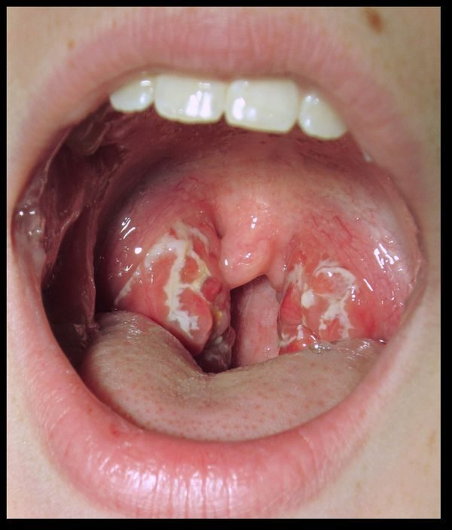
Bacterial pharyngitis (GABHS) L19 slide 73
Gives itself away by: Group A beta-haemolytic Streptococcus · fever, exudate, tender nodes and NO COUGH
Presentation & who gets it30% of pharyngitis; the commonest bacterial cause is group A beta-haemolytic Streptococcus. Common in adolescents and children but not under 3 years. Peaks in winter and spring; droplet spread; incubation 2–5 days. Fever above 100.4 °F, sore throat, cervical lymphadenopathy, dysphagia, odynophagia, LACK OF COUGH, abdominal pain. Tonsillar and pharyngeal erythema with purulent exudate.Pain / where it sits / key findingYes · Tonsils and pharynx · Exudate, fever, tender nodes and NO coughTesting & causeRapid antigen detection test; a negative rapid test is always confirmed with a throat culture. Definitive test is antistreptolysin O, useful because carriers have a positive culture while asymptomatic. Centor criteria (slide 76): age 3–14 +1, age 15–44 0, age 45 or over −1; absence of cough +1; tonsillar exudate +1; fever +1; tender anterior cervical lymphadenopathy +1.First-line treatmentSymptomatic care plus antibiotics: penicillin VK for 10 days, or amoxicillin. Intramuscular penicillin G if compliance or oral intake is a concern. Mild penicillin allergy: cephalexin or cefadroxil. Severe allergy: macrolides or clindamycin.Education & prognosisTreatment is as much about preventing rheumatic fever as about the sore throat.
Slides 73–77

Rheumatic fever Urgent
Gives itself away by: Sequela of untreated GABHS · appears 2–3 weeks after · peak ages 5–15
Presentation & who gets itA rare complication of untreated group A beta-haemolytic streptococcal infection, from cross-reactive antibodies produced against the streptococcus that attack heart muscle — endocarditis, myocarditis or pericarditis. Signs appear 2 to 3 weeks after the infection, sometimes as early as one week or as late as five. Peak incidence between 5 and 15 years; rare before 4 and after 40. Typically resolves after about six weeks.Pain / where it sits / key findingVaries · Heart, joints, skin · 2–3 weeks after an untreated strep throatTesting & causeClinical, against the Jones criteria (slide 79), with evidence of preceding streptococcal infection.First-line treatmentTreat and eradicate the streptococcal infection; manage the carditis.Education & prognosisThis is the reason a sore throat gets an antibiotic at all — the throat would settle without one.
Slides 78–79

Chronic pharyngitis Routine
Gives itself away by: Constant throat clearing · thickened, granular pharyngeal wall with crusting
Presentation & who gets itCauses: postnasal drip from chronic rhinosinusitis, irritants (dust, dry heat, chemicals, smoking, alcohol), chronic mouth breathing, voice abuse, allergy, granulomatous disease, connective tissue disorder, malignancy. Constant throat clearing, dry throat, odynophagia, a thickened and granular pharyngeal wall, and pharyngeal crusting.Pain / where it sits / key findingMild · Pharyngeal wall · Thickened, granular wall with crustingTesting & causeClinical; culture and biopsy if treatment fails.First-line treatmentAddress the underlying disorder, avoid precipitants, treat symptoms.Education & prognosisMalignancy is on the causes list, so failed therapy earns a biopsy rather than another course of something.
Slides 80

Infectious mononucleosis Urgent
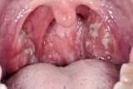
Infectious mononucleosis L19 slide 83
Gives itself away by: Triad: fever, tonsillar pharyngitis, cervical lymphadenopathy · 15–24 years · splenomegaly
Presentation & who gets itHighly contagious; 90–95% of adults are Epstein-Barr virus seropositive. Commonly 15 to 24 years. Spread by oral contact or infected saliva. Epstein-Barr virus in 90%, cytomegalovirus and others in 10%. Prodrome of malaise, headache and low-grade fever — or asymptomatic under 10 years. Triad of fever, tonsillar pharyngitis with or without exudate, and cervical lymphadenopathy. Also palatal petechiae, hepatomegaly, splenomegaly, and a maculopapular rash in 5%.Pain / where it sits / key findingYes · Tonsils and cervical nodes · Fever, tonsillar pharyngitis, cervical adenopathy plus splenomegalyTesting & causeClinical plus confirmation. Monospot / heterophile antibody test is very sensitive and specific — positive means no further testing, but it can be falsely negative in the first week, because heterophile antibodies take about a week to develop. Slide 84 prints “falsely positive”, which is an error. Prof. Shah read it as written at [1:45:26], a student asked whether it was supposed to say false negative, and she confirmed it at [1:47:49]. Minutes earlier she had taught the false-negative pathway herself: “you order that monospot test and you’re like, hold on, that came back NEGATIVE but this patient walks and talks like they have mono… serology will help you”. The same slide already contradicts itself: it sends you to serology for a negative heterophile test in suspected mono, which is the false-negative pathway. Serology: IgG means past infection, IgM means current; useful under 4 years, with a negative heterophile test, or with atypical symptoms. Polymerase chain reaction detects viral DNA.First-line treatmentSupportive — there is no antiviral therapy. Corticosteroids for severe respiratory compromise. Avoid heavy lifting and contact sports for about a month, until the splenomegaly has resolved, to prevent splenic rupture.Education & prognosisGiving penicillin triggers an exanthem — the classic sequence is a sore throat treated as strep, a rash, and then the real diagnosis.
Slides 81–87

Diphtheria Emergent
Gives itself away by: Tenacious GREY MEMBRANE over tonsils and pharynx · unimmunised child
Presentation & who gets itCorynebacterium diphtheriae, attacking the respiratory tract and sometimes mucous membrane or skin wounds, spread by respiratory secretions. Nasal, laryngeal, pharyngeal (commonest) and cutaneous forms. Common in unimmunised children over 6 years. Nasal: discharge. Laryngeal: upper airway and bronchial obstruction. Pharyngeal: a tenacious grey membrane covering tonsils and pharynx, with mild sore throat, fever, malaise, toxaemia and prostration. Complications: myocarditis (arrhythmia, heart block, failure) and neuropathy involving cranial nerves first — diplopia, slurred speech, difficulty swallowing.Pain / where it sits / key findingMild sore throat · Tonsils and pharynx · Tenacious grey membraneTesting & causeClinical, confirmed by culture. Differentiate from streptococcal pharyngitis, mononucleosis, adenovirus, herpes simplex and candidiasis.First-line treatmentLaryngoscopy or bronchoscopy to prevent or relieve obstruction. Antitoxin for all — obtained from the Centers for Disease Control. Penicillin 250 mg four times daily or erythromycin 500 mg four times daily for 14 days. Isolate until three consecutive cultures after therapy are negative. Treat contacts with erythromycin for 7 days.Education & prognosisPrevention is immunisation: childhood schedule plus boosters, and Tdap in every pregnancy between 27 and 36 weeks.
Slides 112–114

5.8 · Deep neck infections

Cervical adenitis Urgent
Gives itself away by: A SIGN, NOT A DIAGNOSIS · typically unilateral, solitary, anterior node
Presentation & who gets itInflammation of a lymph node, often used synonymously with lymphadenopathy. Cervical lymphadenopathy is a sign, not a diagnosis. Infectious causes include toxoplasmosis, tuberculosis, brucellosis, primary herpes simplex, syphilis, cytomegalovirus, HIV, histoplasmosis and chickenpox; also inflammatory, degenerative and neoplastic causes. The typical case is a unilateral, solitary, anterior cervical node: about 70% beta-haemolytic streptococcus, 20% staphylococcus including MRSA, 10% viruses, atypical mycobacteria and Bartonella henselae.Pain / where it sits / key findingVaries — tender means inflammatory · Anterior cervical node · Unilateral solitary node; immobile suggests malignancyTesting & causeResponse to specific antibiotics can help confirm or exclude. Fine needle aspiration if the node persists or keeps enlarging — that can signal malignancy. Describe size, shape, mobility (immobile suggests malignancy), consistency and tenderness (tender = inflammatory, non-tender = malignancy).First-line treatmentTreat the underlying cause. Incision and drainage if there is an abscess.Education & prognosisScarred nodes may stay palpable long after the infection has gone, which is not failure.
Slides 91–94

Peritonsillar abscess (quinsy) Emergent
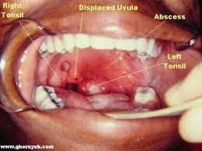
Peritonsillar abscess (quinsy) L19 slide 96
Gives itself away by: Classic triad: TRISMUS, UVULAR DEVIATION, DYSPHONIA · “hot potato” voice
Presentation & who gets itPurulence between the capsule of the palatine tonsil and the pharyngeal muscles, beginning as a complication of untreated strep throat or tonsillitis. The commonest deep infection of the head and neck, especially in young adults, adolescents and children; commoner in males. Aerobes: group A beta-haemolytic streptococcus, Staphylococcus aureus, Haemophilus influenzae. Anaerobes: Prevotella, Porphyromonas, Fusobacterium, Streptococcus. Severe sore throat, fever, odynophagia, medial deviation of the soft palate and peritonsillar fold, uvular deviation, hot potato voice, trismus, dysphagia.Pain / where it sits / key findingSevere · Between tonsil capsule and pharyngeal muscle · Trismus, uvular deviation, hot potato voiceTesting & causeClinical, confirmed by the purulent drainage obtained. Contrast computed tomography shows the extent; ultrasound distinguishes abscess from cellulitis and can guide needle aspiration.First-line treatmentSecure the airway first if needed. Needle aspiration and incision and drainage. Antibiotics: parenteral amoxicillin-clavulanate or clindamycin, adding MRSA cover if severe; oral if tolerated. Tonsillectomy for recurrent tonsillitis and recurrent abscesses, usually after the acute infection settles — quinsy tonsillectomy during infection is occasional.Education & prognosisTrismus is the most reliable symptom; the dysphonia comes from vagus nerve involvement failing to elevate the palate.
Slides 96–101

Retropharyngeal abscess Emergent
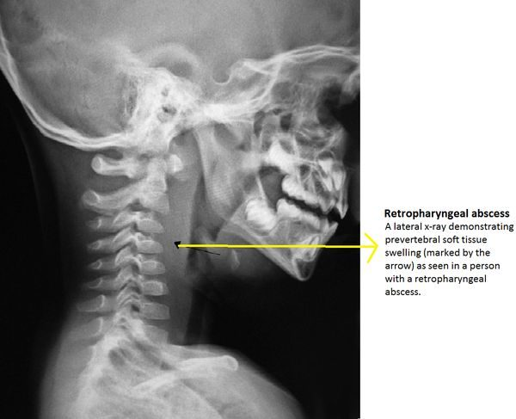
Retropharyngeal abscess L19 slide 105
Gives itself away by: SURGICAL EMERGENCY · child under 5 · widened retropharyngeal space on lateral neck X-ray
Presentation & who gets itAn abscess in the retropharyngeal space, running from the base of skull to the posterior mediastinum. May spread from a peritonsillar abscess or from a node in that space. Commoner in children under 5 after upper respiratory infection, otitis media or sinusitis; in adults it follows intraoral procedures, trauma, foreign bodies such as fishbone, immunocompromise or odontogenic spread. Group A beta-haemolytic streptococcus, Staphylococcus aureus, Haemophilus influenzae, mixed flora. Early: fever, sore throat, pharyngeal erythema, dysphagia, odynophagia, neck stiffness, trismus. Late: ill appearance, drooling, leaning forward with the neck extended, respiratory distress.Pain / where it sits / key findingYes · Retropharyngeal space · Widened retropharyngeal space on lateral X-rayTesting & causeLabs; lateral neck X-ray shows a widened retropharyngeal space; lateral neck computed tomography is the gold standard, showing a rim-enhancing hypodense collection. Distinguishing abscess from adenitis is the point.First-line treatmentProtect the airway. Surgical emergency. Antibiotics covering streptococci, anaerobes and Staphylococcus aureus: ampicillin-sulbactam, or clindamycin with ceftriaxone; vancomycin or linezolid if not improving; switch to oral on clinical improvement.Education & prognosisMediastinitis carries 50% mortality. Other complications: respiratory distress, rupture with aspiration pneumonia, and spread into the danger space, which is continuous left to right and leads directly to the thorax.
Slides 103–107

Ludwig angina Emergent
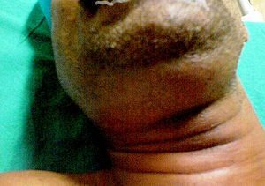
Ludwig angina L19 slide 109
Gives itself away by: EMERGENCY · floor of mouth, submental, sublingual and submandibular spaces · TONGUE PUSHED UP AND BACK
Presentation & who gets itA severe infection of the floor of the mouth and the submental, sublingual and submandibular spaces. Can rapidly compromise the upper airway and force a surgical airway. Streptococci, staphylococci, Bacteroides, Fusobacterium, Klebsiella — the last usually in patients with diabetes, who have a more aggressive course. Oedema and erythema of the upper neck under the chin and the floor of the mouth; the tongue is displaced upwards and backwards by posterior spread of cellulitis; pus coalescing at the floor of the mouth.Pain / where it sits / key findingYes · Floor of mouth, submental and submandibular · Tongue displaced up and backTesting & causeComputed tomography with contrast, to separate inflammation and phlegmon from abscess and define the extent for the surgeon.First-line treatmentAntibiotics: penicillin with metronidazole, ampicillin-sulbactam, clindamycin, or selected cephalosporins. External drainage via bilateral submental incision if the airway is threatened or medical therapy fails. Dental consultation to deal with the offending tooth.Education & prognosisIt is usually odontogenic, which is why the dental referral is part of the treatment rather than an afterthought.
Slides 108–111

5.9 · Dentition and the jaw

Dental abscess Urgent
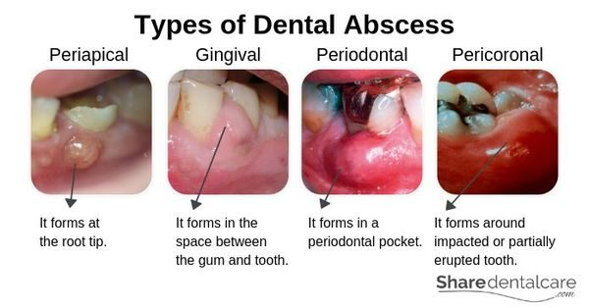
Dental abscess L19 slide 116
Gives itself away by: Pus inside the tooth or gums · from bacterial infection of the soft pulp
Presentation & who gets itA build-up of pus inside the teeth or gums, from bacterial infection accumulating in the soft pulp of the tooth. Slide 116 divides them into periapical (at the root tip), gingival (in the space between gum and tooth), periodontal (in a periodontal pocket) and pericoronal (around an impacted or partially erupted tooth).Pain / where it sits / key findingYes · Tooth pulp or gum · Periapical, gingival, periodontal or pericoronal pusTesting & causeClinical, with dental imaging.First-line treatmentAntibiotics — amoxicillin, ampicillin-sulbactam, amoxicillin-clavulanate, azithromycin, clindamycin, erythromycin, cephalexin, metronidazole, penicillin VK. Incision and drainage. Root canal if the tooth can be restored; extraction with curettage of apical tissue if it cannot.Education & prognosisUntreated, infection from a tooth can spread to the jaw, the brain or the sinus — and Ludwig angina is the neck version of that spread.
Slides 116–117

Dental caries, pulpitis and periapical abscess Urgent
Gives itself away by: Tooth decay is the commonest cause; injury second · severe inflammation kills the pulp
Presentation & who gets itCommon teeth diseases are cavities, pulpitis, periapical abscess, impacted teeth and malocclusion. The commonest cause of pulpitis and periapical abscess is tooth decay, and the second commonest is injury. Mild inflammation, if relieved, may not damage the pulp permanently; severe inflammation kills it. Pulpitis can lead to a pocket of pus at the root — a periapical abscess.Pain / where it sits / key findingYes · Tooth · Decay first, injury secondTesting & causeClinical and dental imaging.First-line treatmentDental treatment of the decay; root canal or extraction as for dental abscess.Education & prognosisUntreated, infection from a tooth can spread to the jaw or beyond — brain or sinus.
Slides 123–124

Gingivitis and periodontitis Routine
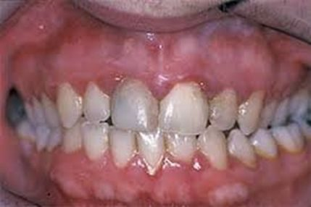
Gingivitis and periodontitis L19 slide 122
Gives itself away by: Gums erythematous, oedematous and BLEED EASILY with little discomfort · gingivitis is REVERSIBLE
Presentation & who gets itChronic infection of the gingiva beginning with bacterial plaque at the gum line. Gingivitis is the mildest form: erythematous, oedematous gums that bleed easily, with little or no discomfort, caused by inadequate oral hygiene — and reversible with professional treatment and good home care. Untreated it becomes periodontitis: plaque spreads below the gum line, bacterial toxins provoke a chronic inflammatory response in which the body turns on itself, gums separate from teeth, pockets form and become infected, the periodontal ligament and bone are destroyed, and teeth loosen and fall out. Risk: diabetes, smoking, ageing, genetics, stress, poor nutrition, puberty, pregnancy, substance abuse, HIV and certain medications. Gram-negative organisms.Pain / where it sits / key findingLittle to none · Gum line · Gums bleed easily; gingivitis is reversibleTesting & causeClinical and dental examination.First-line treatmentProfessional cleaning and oral hygiene — brushing, flossing, mouthwash — and modifying risk.Education & prognosisPeriodontal disease and dental caries are the primary causes of tooth loss. The slides also link gum disease to endocarditis risk, pneumonia, osteoporosis and, in men, kidney, pancreatic and blood cancers.
Slides 118–122

Impacted teeth Routine
Gives itself away by: Overcrowding · wisdom teeth are the usual ones · more likely to become infected
Presentation & who gets itImpaction is usually caused by overcrowding and insufficient room for a new tooth to emerge. Wisdom teeth are the usual culprits, being the last permanent teeth to erupt into a jaw that may not accommodate them. Impacted teeth are more likely to become infected.Pain / where it sits / key findingVaries · Usually wisdom teeth · Overcrowding with no room to eruptTesting & causeClinical and dental imaging.First-line treatmentUsually removed — they are of little use in chewing.Education & prognosisA pericoronal abscess is the complication that links this row to the dental abscess row.
Slides 125

Malocclusion Routine
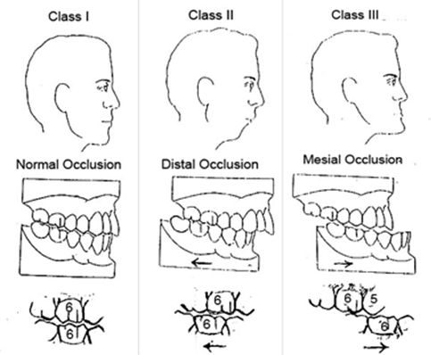
Malocclusion L19 slide 126
Gives itself away by: Abnormal alignment of teeth and bite · Class I, II and III
Presentation & who gets itAbnormal alignment of the teeth and the way upper and lower teeth fit together. Normal chewing produces about 150 lb of force on the molars, and about 250 lb when clenching during sleep; if that force is unevenly distributed, teeth wear, fracture or loosen. Causes: size mismatch between jaw and teeth, thumb sucking or tongue thrusting, lost teeth, birth defects. Slide 126 illustrates Class I normal occlusion, Class II distal occlusion and Class III mesial occlusion.Pain / where it sits / key findingNo · Bite · Class I, II or III occlusionTesting & causeClinical and dental assessment.First-line treatmentBraces or aligners, removal of teeth, or surgery.Education & prognosisThe force numbers are the reason a bite problem becomes a structural one.
Slides 126

Temporomandibular joint disorders Routine
Gives itself away by: Second commonest musculoskeletal cause of pain and disability · jaw pain with clicking, popping or locking
Presentation & who gets itDisorders affecting the temporomandibular joint, the masticatory muscles, or both. The second commonest musculoskeletal condition causing pain and disability. Common in women of childbearing age, with a possible link to female sex hormones. Predisposing: trauma — a blow to the jaw or whiplash — and stress, which disrupts sleep and increases nocturnal bruxism. Perpetuated by stress, poor coping, clenching and grinding, and poor posture. Three categories: myofascial pain, internal derangement (displaced disc, dislocated jaw, condylar injury), and arthritis. Jaw, face and head pain; limited opening, catching or locking; clicking, popping or grating; headache, neck and shoulder pain; tinnitus, ear fullness, hearing loss, dizziness; abnormal tooth wear and sensitivity.Pain / where it sits / key findingYes · Temporomandibular joint and muscles · Clicking, popping or locking with limited openingTesting & causeClinical. Computed tomography or magnetic resonance imaging is reserved for abnormal pain or dysfunction not responding to short-term therapy, or a sudden change in bite or mandibular asymmetry.First-line treatmentEliminate pain and restore function: self care; non-steroidal anti-inflammatories, muscle relaxants (cyclobenzaprine), low-dose tricyclics (amitriptyline, desipramine, nortriptyline); oral steroids if there is synovitis; physical therapy, transcutaneous electrical nerve stimulation, acupuncture, local anaesthesia, mouth guards, arthrocentesis, arthroscopy, surgery.Education & prognosisThe ear symptoms are the trap — tinnitus, fullness and dizziness send these patients to an ear examination that is normal.
Slides 128–131

5.10 · Lesions of the oral cavity

Oral candidiasis (thrush) Routine
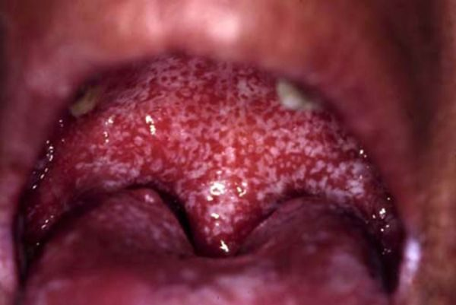
Oral candidiasis (thrush) L19 slide 89
Gives itself away by: Creamy white curd-like patches that WIPE OFF, leaving an erythematous base
Presentation & who gets itCandida albicans; Aspergillus may also be cultured. Common in infants and the immunosuppressed. Risk factors: dentures, poor oral hygiene, diabetes, anaemia, chemotherapy or local irradiation, corticosteroids, broad-spectrum antibiotics, age, HIV. Creamy white curd-like patches on an erythematous base, painful, granular, usually on buccal mucosa and tongue, with fever, lymphadenopathy, odynophagia and taste change.Pain / where it sits / key findingYes · Buccal mucosa and tongue · White patches that RUB OFFTesting & causeClinical. Potassium hydroxide preparation shows spores and pseudohyphae.First-line treatmentSaline and peroxide washes; topical antifungals — nystatin suspension, clotrimazole, ketoconazole, fluconazole. HIV patients may need longer fluconazole; refractory disease needs itraconazole or voriconazole.Education & prognosisThe patches rub off with a tongue depressor. Leukoplakia and lichen planus do not — that single manoeuvre separates three diagnoses.
Slides 88–90

Oral leukoplakia Urgent
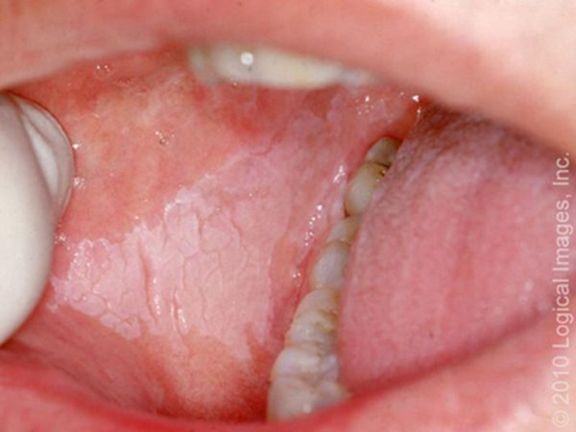
Oral leukoplakia L19 slide 133
Gives itself away by: White lesion that CANNOT be scraped off · premalignant — 5–20% become squamous cell carcinoma
Presentation & who gets itA premalignant squamous lesion: altered epithelium at increased risk of progression to squamous cell carcinoma, 5–20%. Defined as a white lesion of the oral mucosa that cannot be scraped off and cannot be attributed to another definable lesion. Causes include chronic irritation, smoking and infection.Pain / where it sits / key findingNo · Oral mucosa · White and CANNOT be scraped offTesting & causeExcisional biopsy to rule out malignancy. Complete intraoral examination and palpation for lymphadenopathy.First-line treatmentObservation after eliminating carcinogenic irritants — smoking, chewing tobacco, alcohol — with serial biopsies and excisions.Education & prognosisThe scrape test is the bedside discriminator: candidiasis wipes off, leukoplakia does not.
Slides 133–134

Erythroplakia Emergent
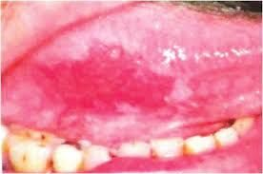
Erythroplakia L19 slide 135
Gives itself away by: Like leukoplakia but RED · 90% are dysplastic or carcinoma · far more dangerous
Presentation & who gets itAs leukoplakia but with an erythematous component. 90% are either dysplastic or already carcinoma, and the risk of malignancy is around 25% — substantially higher than leukoplakia. Alcohol and tobacco are the major risk factors.Pain / where it sits / key findingNo · Oral mucosa · Red — 90% dysplastic or carcinomaTesting & causeAs for leukoplakia — excisional biopsy.First-line treatmentAs for leukoplakia, but the threshold for excision is lower.Education & prognosisRed is worse than white. If one lesion on the slide deck earns urgency, it is this one.
Slides 133, 135

Hairy leukoplakia Urgent
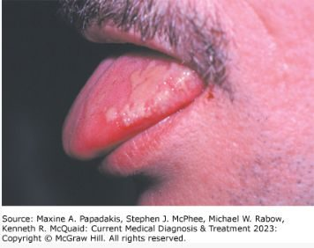
Hairy leukoplakia L19 slide 136
Gives itself away by: Painless LATERAL TONGUE lesion that waxes and wanes · EBV · strongly associated with HIV
Presentation & who gets itBenign mucosal hyperplasia associated with Epstein-Barr virus, long-term systemic corticosteroids and solid organ transplantation. Strongly associated with HIV and a common early finding in HIV infection. Painless lateral tongue lesions that wax and wane over time.Pain / where it sits / key findingNo — painless · Lateral tongue · Waxes and wanes; think HIVTesting & causeClinical and biopsy.First-line treatmentObservation. Acyclovir, valacyclovir or famciclovir produce temporary resolution.Education & prognosisThe lesion itself is benign; its value is as a pointer to undiagnosed HIV.
Slides 136

5.11 · Neoplasms

Salivary gland neoplasm Urgent
Gives itself away by: Slow-growing PAINLESS mass at the TAIL OF THE PAROTID · the smaller the gland, the likelier it is malignant
Presentation & who gets it64–80% arise in the parotid, and 75–80% of those are benign. 7–15% submandibular, 50–60% benign. 1% sublingual. About 15% are minor salivary gland, and only 35% of those are benign. Most benign parotid tumours are epithelial; in minor glands the commonest is pleomorphic adenoma, then basal cell adenoma. Malignant disease is 3–4% of head and neck malignancy; mucoepidermoid carcinoma is the commonest, and in minor glands adenoid cystic carcinoma and adenocarcinoma. No specific risk factors are known. Benign parotid tumours are slow-growing painless masses often at the tail of the parotid.Pain / where it sits / key findingNo — painless · Tail of the parotid · Slow-growing painless mass; pain suggests malignancyTesting & causeFine needle aspiration is less specific and sensitive here than for other tumours, though it helps separate malignant from benign. Diffusion-weighted magnetic resonance imaging or computed tomography helps with deep lobe tumours.First-line treatmentBenign: complete surgical excision, no radiation. Malignant: surgical removal, radiotherapy for T1 and T2, palliative chemotherapy. Complications include recurrence with positive margins and transient or permanent facial paralysis.Education & prognosisPrognosis is poor with pain, facial or other nerve involvement, high-grade histology, skin or tissue invasion, or recurrent disease.
Slides 139–143

Oral cavity and oropharyngeal cancer Emergent
Gives itself away by: NON-HEALING ULCER · tobacco and alcohol · referred otalgia and ill-fitting dentures in advanced disease
Presentation & who gets itOral cavity means the anterior two thirds of tongue, buccal mucosa, floor of mouth, hard palate, upper and lower gingiva and retromolar trigone — the lip is no longer part of the oral cavity under the 8th staging system. Oropharynx means posterior third of tongue, palatine tonsil, soft palate and posterior pharyngeal wall. Males are 2–4 times more likely for oral cavity and 3–5 times for oropharyngeal. 60–80% of oropharyngeal cancer is human papillomavirus related; 90% of oral cavity cases relate to chronic sun exposure. Mean age 62. Risks: tobacco chewed and smoked, alcohol, betel nut, poor oral hygiene, immunosuppression. Squamous cell carcinoma is commonest; lymphoma is the second commonest tumour of the tonsillar fossa. Non-healing ulcers, bleeding, pain, ill-fitting dentures; advanced: dysarthria, dysphagia, neck mass, referred otalgia from cranial nerve involvement; tonsillar lesions give odynophagia and trismus.Pain / where it sits / key findingVaries · Tongue, floor of mouth, tonsil · Non-healing ulcer with referred otalgiaTesting & causeLabs including high-risk human papillomavirus testing and in situ hybridisation; computed tomography or magnetic resonance imaging for the primary and nodes; chest X-ray and positron emission tomography for metastases; flexible fiberoptic endoscopy; biopsy; dental evaluation.First-line treatmentSurgical resection alone for oral cavity; resection plus radiotherapy for oropharyngeal, where radiotherapy gives better functional outcomes.Education & prognosisPrevention is tobacco and alcohol cessation. An ulcer that has not healed is the symptom that should never be watched.
Slides 144–148

